4/25/2020

Developing Mobile Application

Assignment 40%

Sujan Aryal

S id: C7190077

Teacher: Nutan madasaini

The British College

Leeds Beckett university

Table of Contents

What is Android? 3

Android is an operating system 3

Simple To-do app Documentation 4

App Screenshots 4

Things included in this app 5

Features of the app 5

Functions used in this app 6

App xml activities and Class 7

Splash Screen xml 7

Splash Screen java class 8

Main activity xml 8

Main activity java class 9

Register activity xml 9

Register activity java class 10

Dashboard activity xml 10

Dashboard activity java class 11

About activity xml 11

About activity java class 12

Contact activity xml 12

Contact activity java class 13

Add To-do activity xml 13

Add To-do activity java class 14

Home/View/Add To-do activity xml 14

Add To-do activity java class 15

To-do Detail activity xml 16

To-do Detail activity java class 16

Profile activity xml 17

MVVM Admin Login xml 17

Fragments 18

Profile activity java class 19

Empty field Validations and toast message 19

Database Helper class 20

Progress bar Animation java class 20

Colors xml activity 21

Strings xml activity 21

Todo Using Orm +room + live data 22

Additional Screenshots 29

# What is Android?

## Android is an operating system

Android isn’t a phone or an application, but an operating system based on the Linux kernel. No clue what that is? In its most simplistic definition, Linux is an operating system most commonly found on servers and desktop computers. Android isn’t just a version of Linux, due to the many changes found under the hood, but it is related.

So android is an operating system designed with mobile in mind, the place where your phone’s functions and applications live. Everything you see on the display of your device is a part of the operating system. When you get a call, text message, or email, the OS processes that information and puts it in a readable format.

The Android OS is divided into various version numbers, implying significant jumps in features, operation, and stability, which usually have codenames. So, if you hear someone say Android Marshmallow, Nougat, Oreo, Pie, or the latest Android 10, which is just the name of the version of Android you might have on your device.

Most modern smartphones and tablets released this year run Android 9 Pie or Android 10, with the latter platform particularly being common on the more recent handsets like the OnePlus 7T series and the latest Pixel handsets from Google.

Most Android device manufacturers, such as Samsung, HTC, Motorola, Sony, OnePlus, and numerous others, usually have a skin on top of the OS. A skin, or UI overlay, is basically a custom design that adds extra features to your phone, different icons, and other tweaks designed to provide an experience unique to your chosen phone maker. The most popular skins include Samsung’s One UI, OnePlus’ Oxygen OS, and Huawei’s EMUI. A phone without any major customizations is generally referred to as “stock Android”, and UIs with only minor changes (such as found with Motorola phones) are often called near-stock.

## Simple To-do app Documentation

### App Screenshots

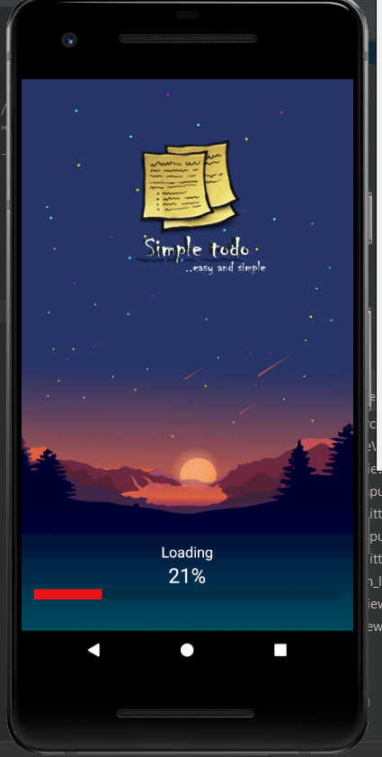 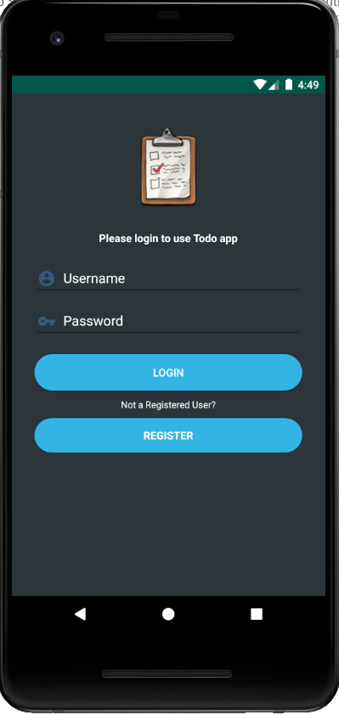 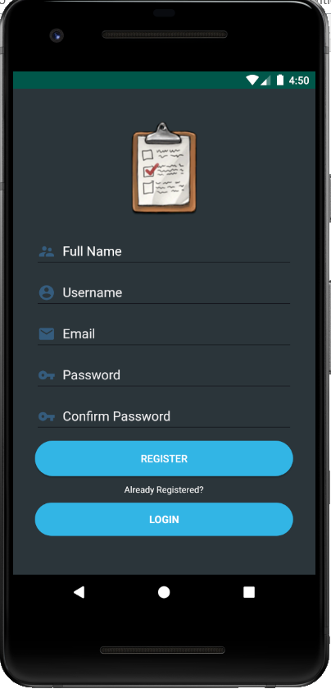

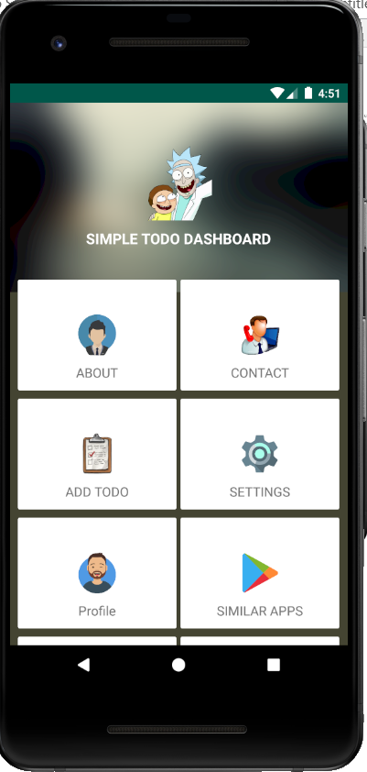 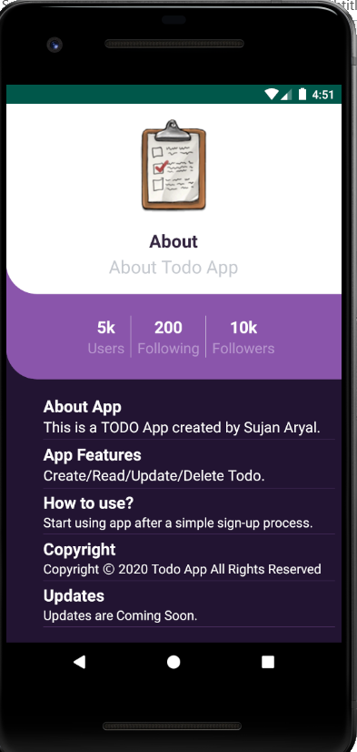 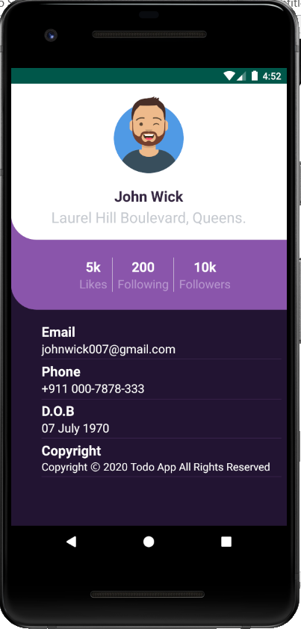

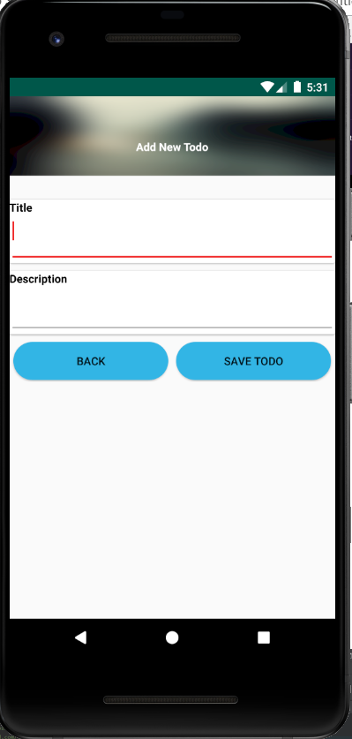 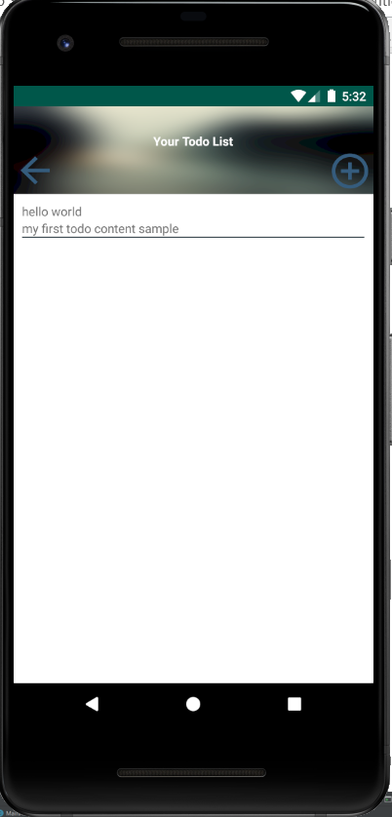 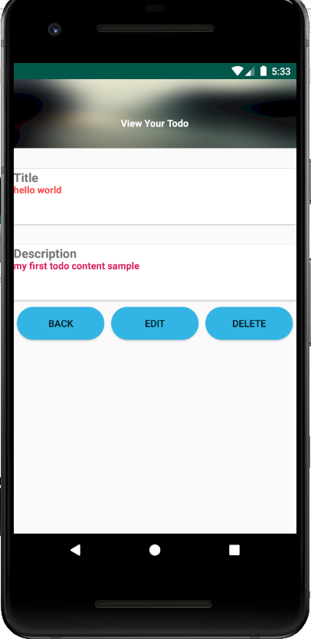

**The above screenshots contains how the app looks like and what’s its purpose.**

**Note: In order to use the app user has to register first**

### Things included in this app

* Splash screen
* Login and logout
* Register
* Crud operation, validation, toast
* Dashboard
* About
* To-do list
* Contact and so on…
* Mvvm
* Fragments

### Features of the app

* User Registration and login
* To-do adding feature
* Edit feature
* Delete feature
* View feature
* User profile
* And some useful linked activities

# Functions used in this app

Note: In order to create this app for the lab exercise and assignment following functions are used and implemented.

* On click listener function
* Android life cycle log
* Toast
* Text Utlis Is Empty
* Splash screen animation
* Sqlite database
* Listview
* Alert Dialog box
* Intent
* Package Manager
* etc

**On click listener function**: Interface definition for a callback to be invoked when a view is clicked.

**Android life cycle**: To navigate transitions between stages of the activity **lifecycle**, the Activity class provides a core set of six callbacks: on Create() , on Start() , on Resume() , on Pause() , on Stop() , and on Destroy() . The system invokes each of these callbacks as an activity enters a new state.

**Toast:** Android Toast can be used to display information for the short period of time. A toast contains message to be displayed quickly and disappears after sometime.

**Text Utlis Is Empty:** TextUtils is simply a set of utility functions to do operations on String objects.

**Splash screen animation:** it is a graphical control element consisting of a window containing an image, a logo, and the current version of the software. A splash screen usually appears while a game or program is launching.

**SQLite database: SQLite** is an open-source relational **database** i.e. used to perform **database** operations on **android** devices such as storing, manipulating or retrieving persistent data from the **database**. It is embedded in **android** bydefault. So, there is no need to perform any **database** setup or administration task.

**List view: Android List View** is a **view** which groups several items and display them in vertical scrollable **list**. The **list** items are automatically inserted to the **list** using an Adapter that pulls content from a source such as an array or database.

**Alert Dialog box: Android Alert Dialog** can be used to display the **dialog** message with OK and Cancel buttons. It can be used to interrupt and ask the user about his/her choice to continue or discontinue. **Android Alert Dialog** is composed of three regions: title, content area and action buttons.

**Intent:** An **Intent** is a simple message object that is used to communicate between **android** components such as activities, content providers, broadcast receivers and services. Intents are also used to transfer data between activities. Intents are used generally for starting a new activity using start Activity ().

**Package Manager:** Class for retrieving various kinds of information related to the application packages that are currently installed on the device.

**Note: Package manager is used in this app to open settings, gmail etc.**

## App xml activities and Class

### Splash Screen xml

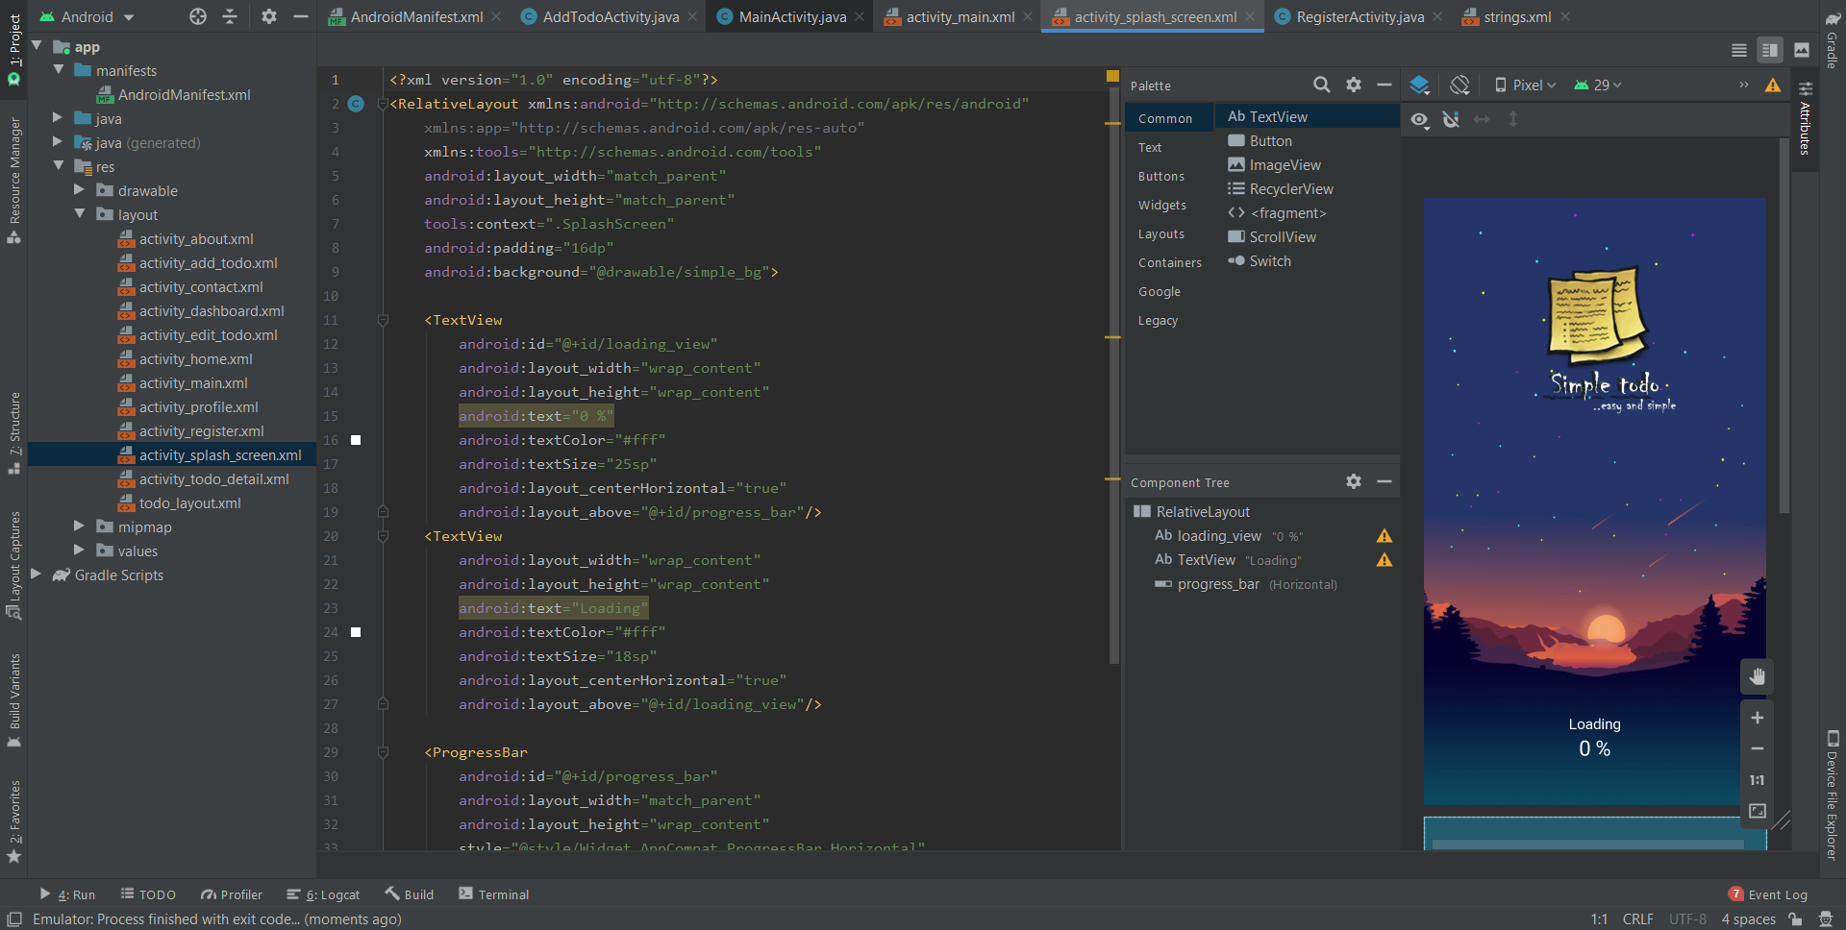

**This is splash screen which means** it is a graphical control element consisting of a window containing an image, a logo, and the current version of the software. A splash screen usually appears while a game or program is launching. This screenshot contains the layout of the splash screen and things included like text view, logo, and background image and so on.

### Splash Screen java class

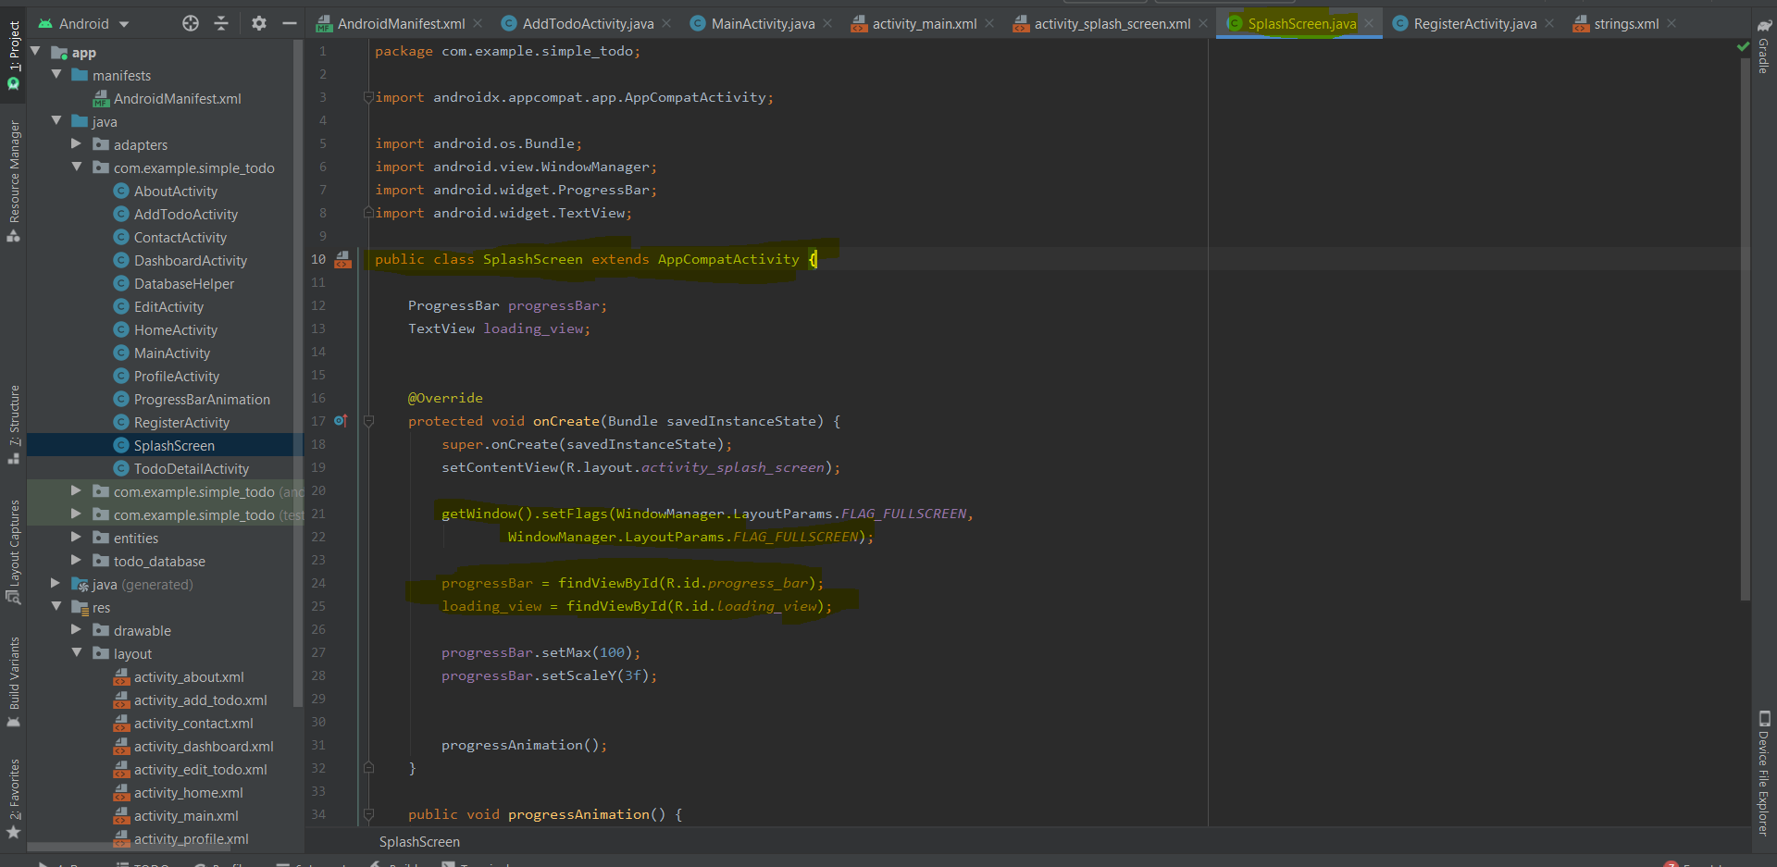

This is splash screen java class contains how the animation of splash screen works.

### Main activity xml

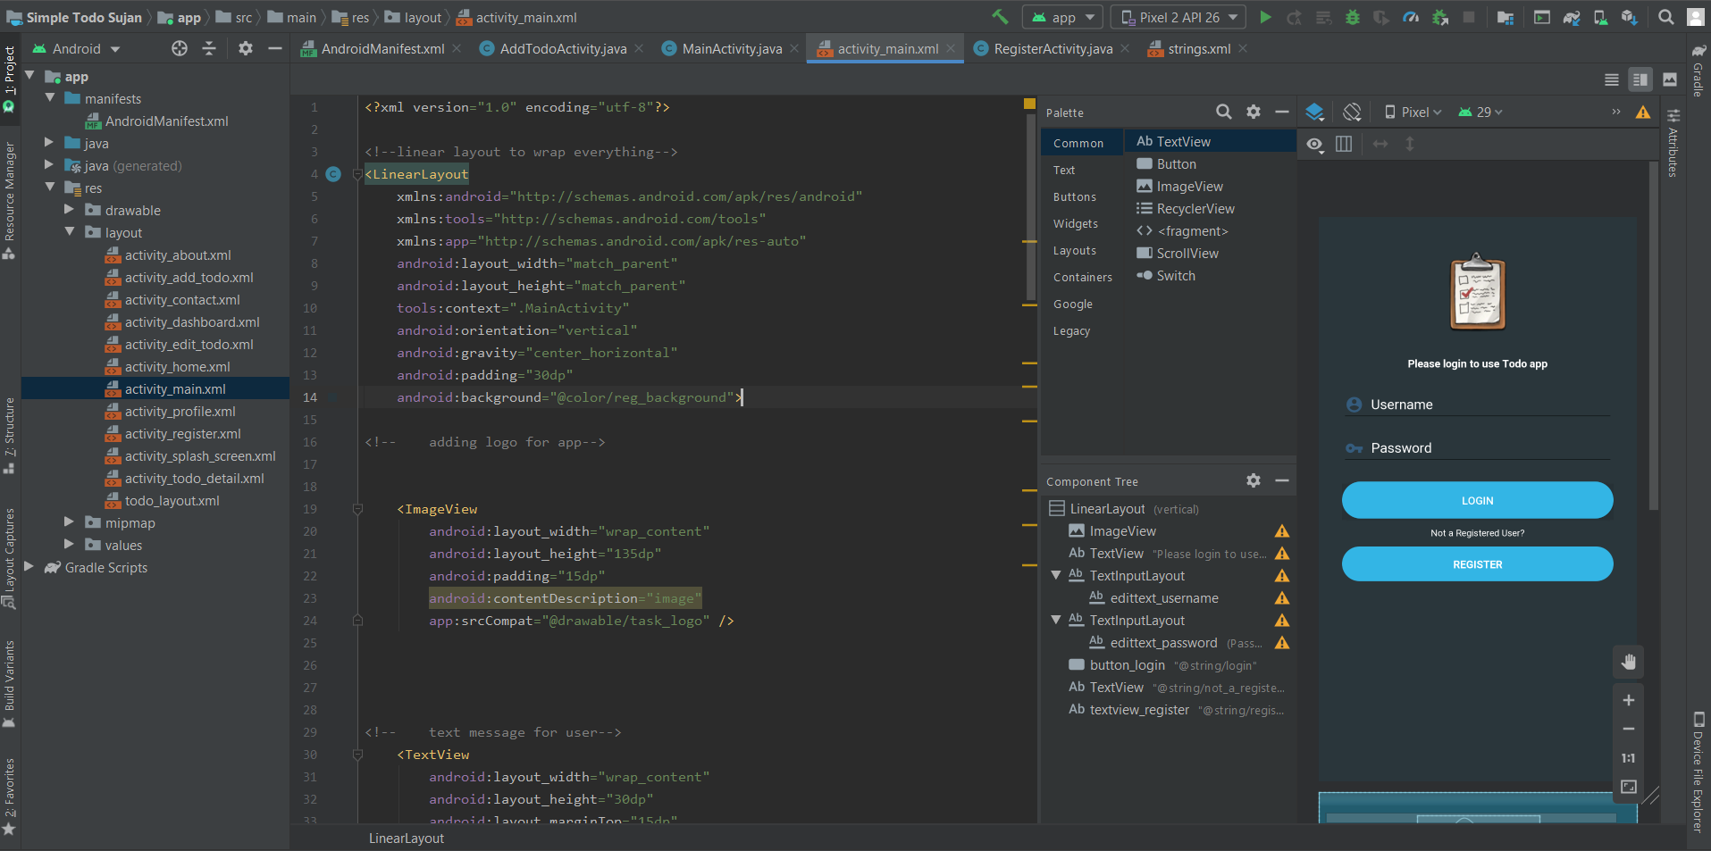

This is the main activity xml screenshot which includes the login design layout containing logo, edit text, text input, and button design and so on.

### Main activity java class

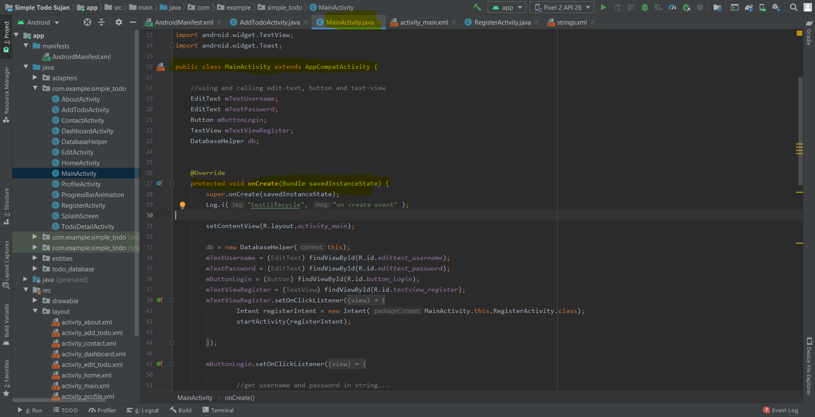

This is Main activity java class contains how the login process works and how the fields are validated along with the database helper.

### Register activity xml

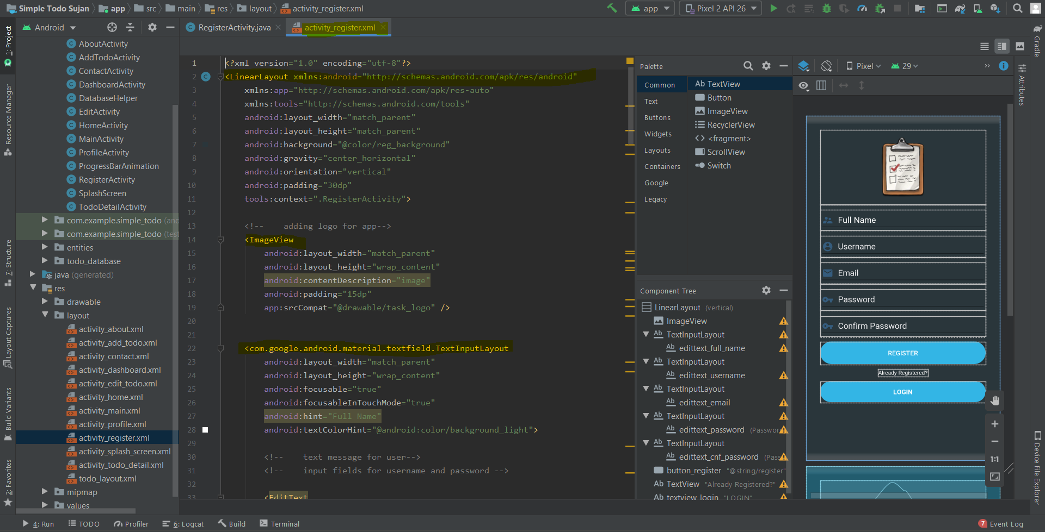

This is the register activity xml screenshot which includes the register design layout containing logo, edit text, text input, and button design and so on.

### Register activity java class

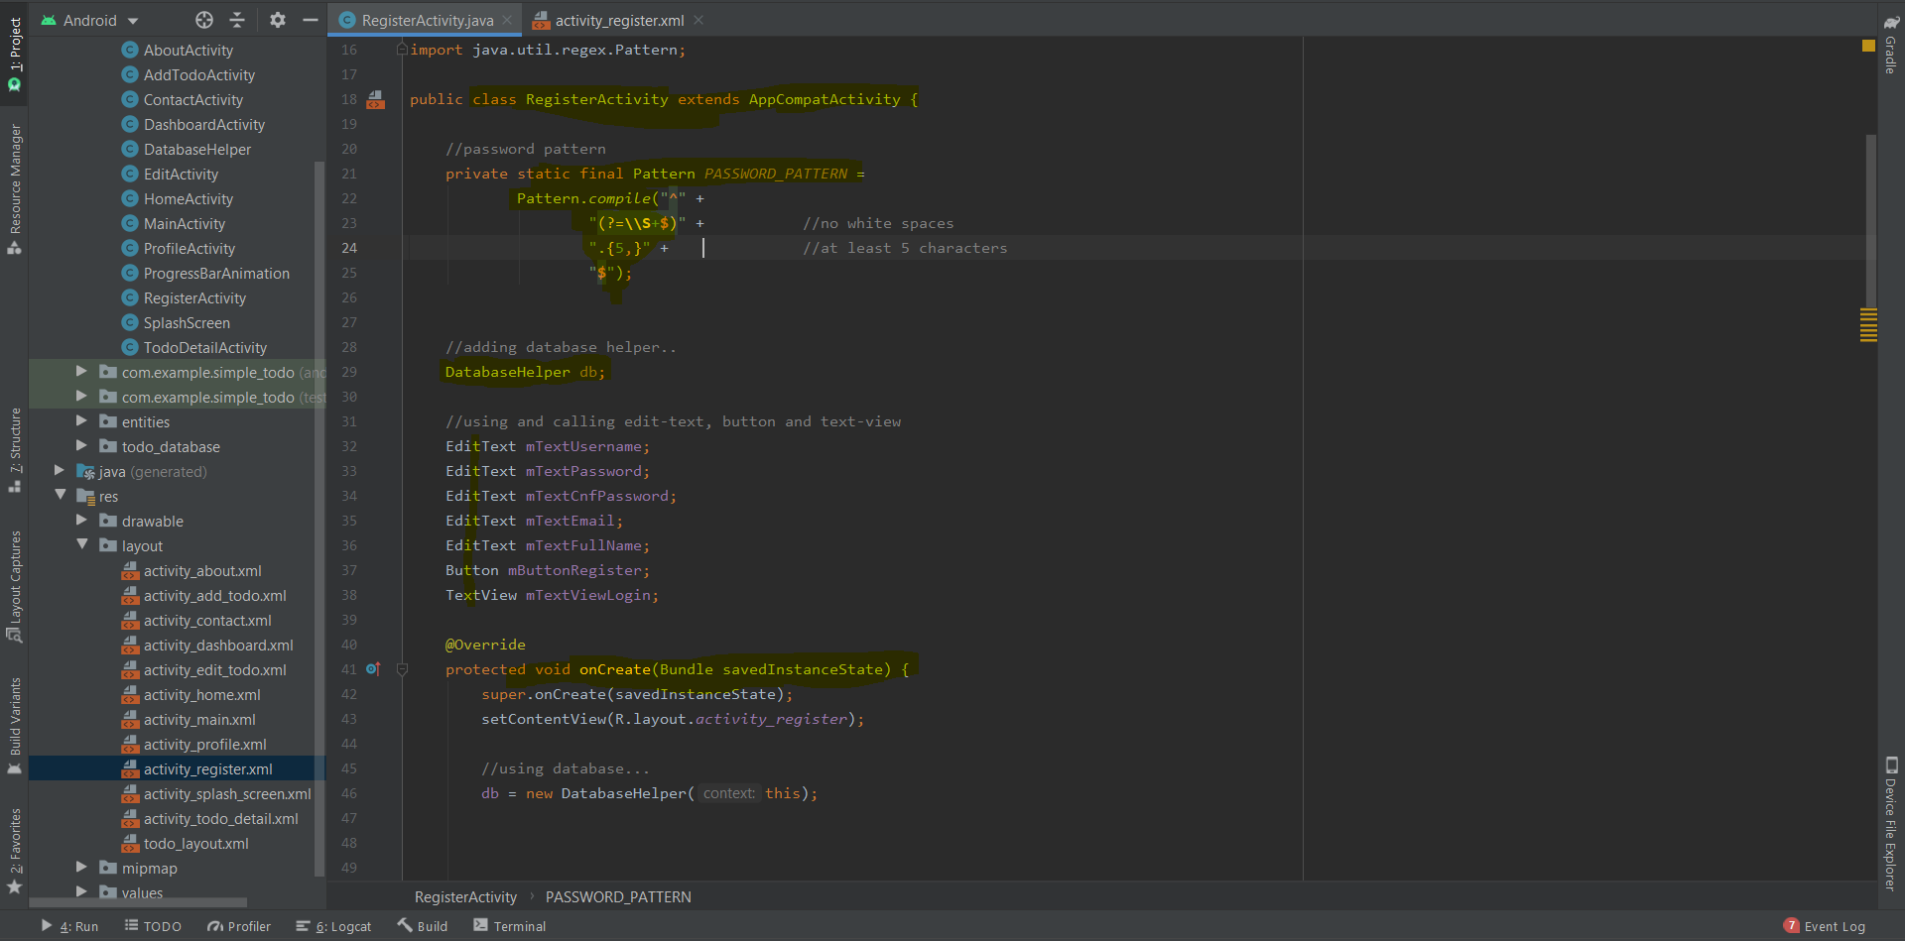

This is Register activity java class contains how the register process works and how the fields are validated along with the database helper there is password pattern matcher to validate i.e. which prevents invalid data insertion.

### Dashboard activity xml

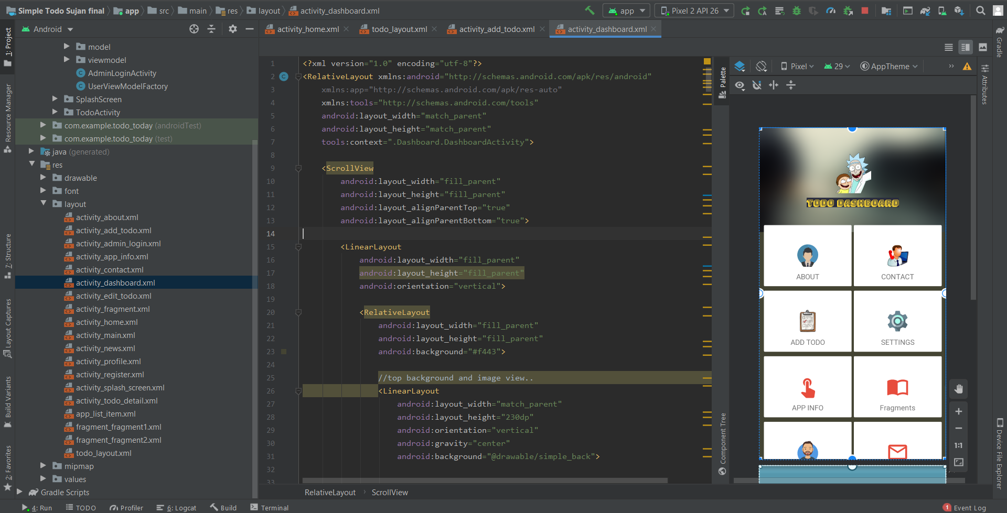

This is the dashboard activity xml screenshot which includes the dashboard design layout containing logo, icons, different buttons with on click function and many more.

### Dashboard activity java class

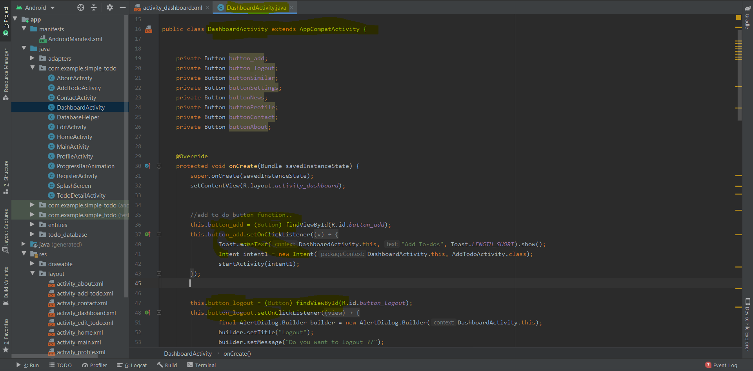

This is Dashboard activity java class contains how the dashboard process works and how the buttons functions with different button and icons to open activities with on click function there are 8 buttons with different on click functions.

### About activity xml

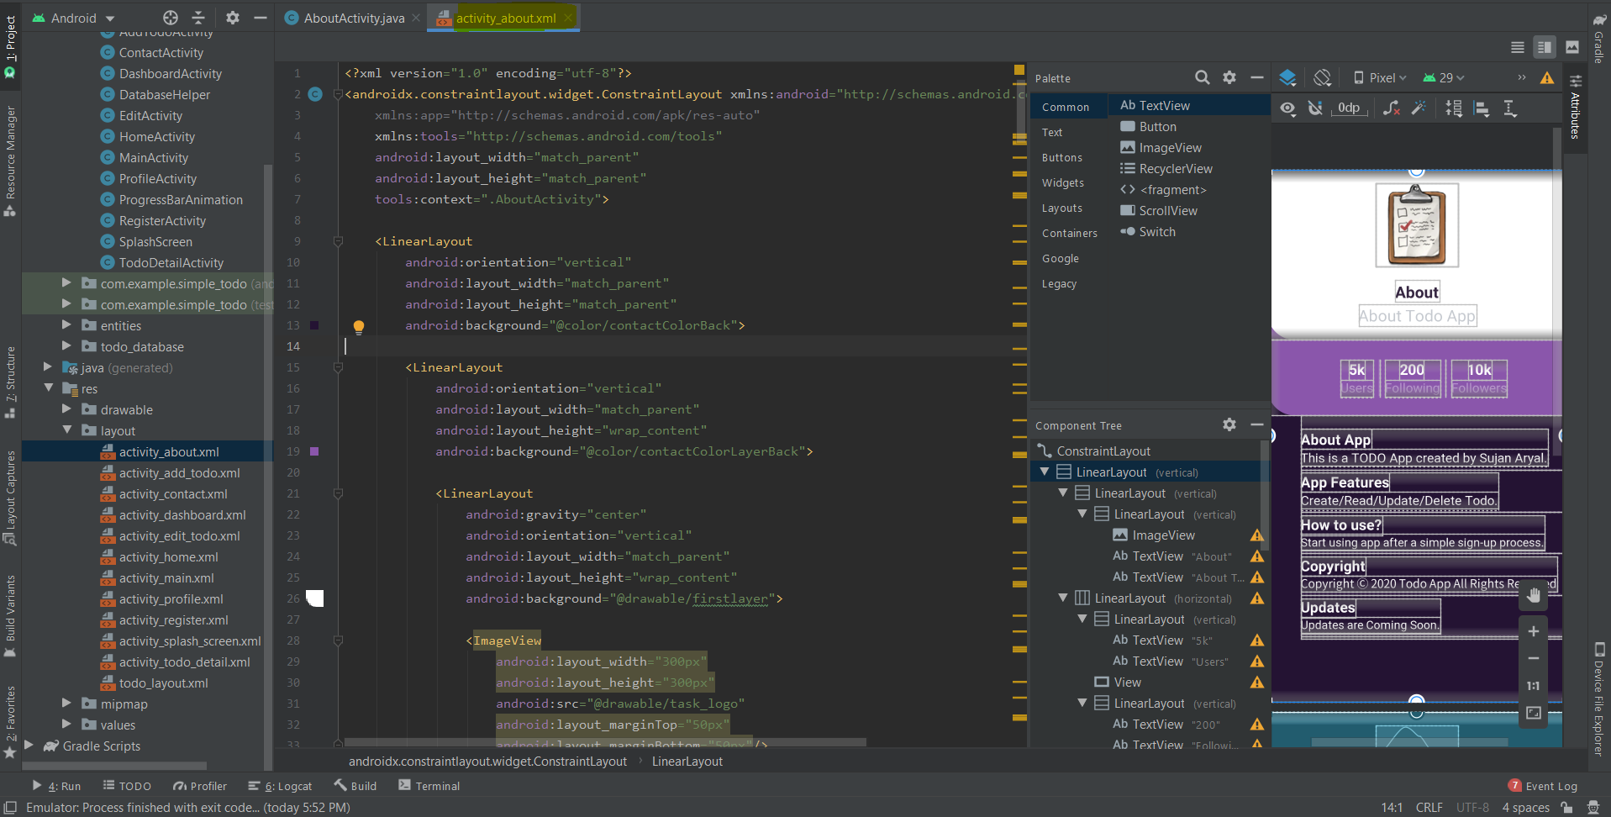

This is the about activity xml screenshot which includes the about design layout containing logo and information about app.

### About activity java class

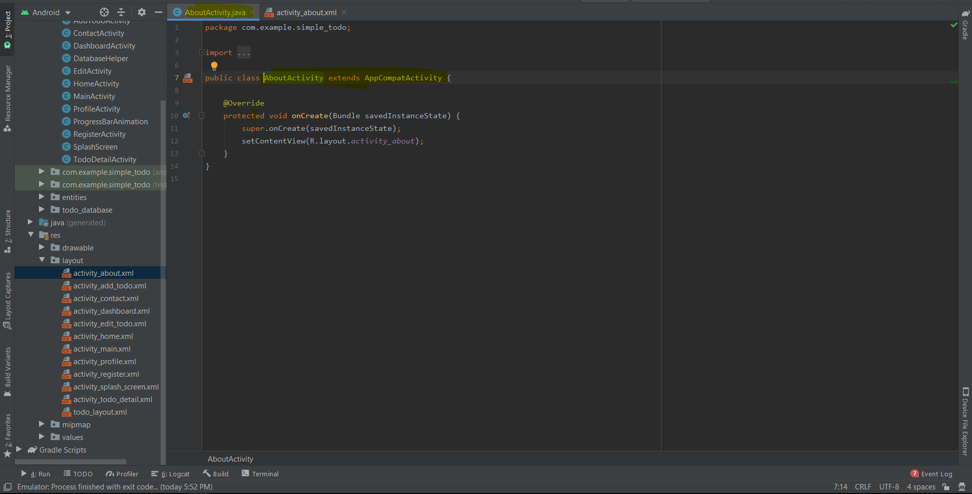

This is java class of about activity which has no dynamic content for now all the layout is managed through xml file.

### Contact activity xml

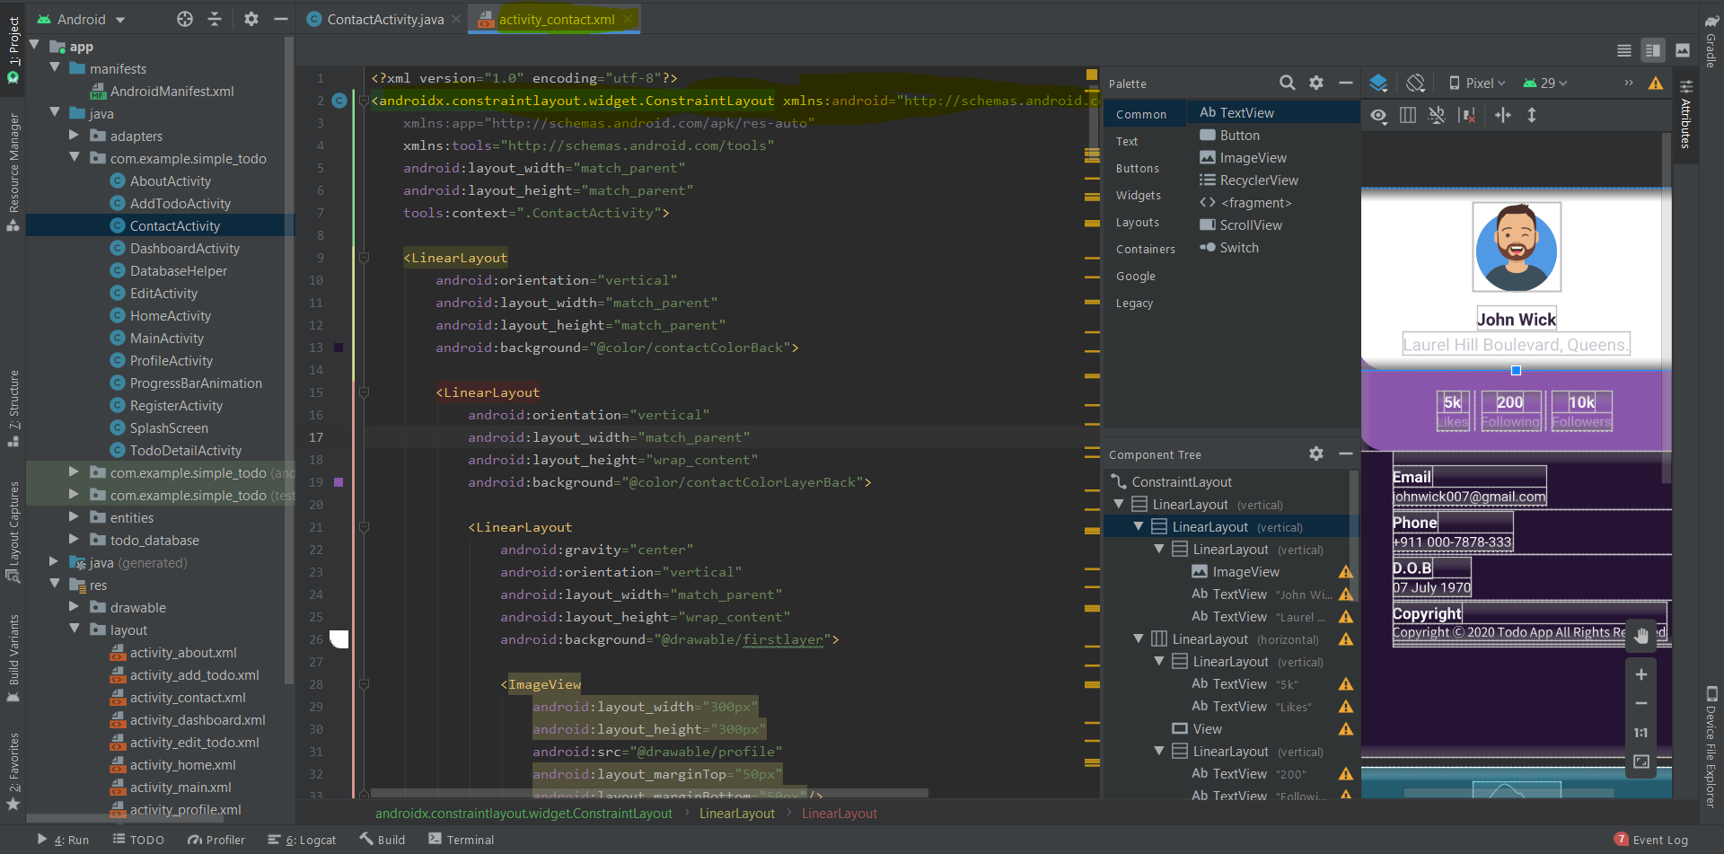

This is the contact activity xml screenshot which includes the contact design layout containing logo and information about developer of app.

### Contact activity java class

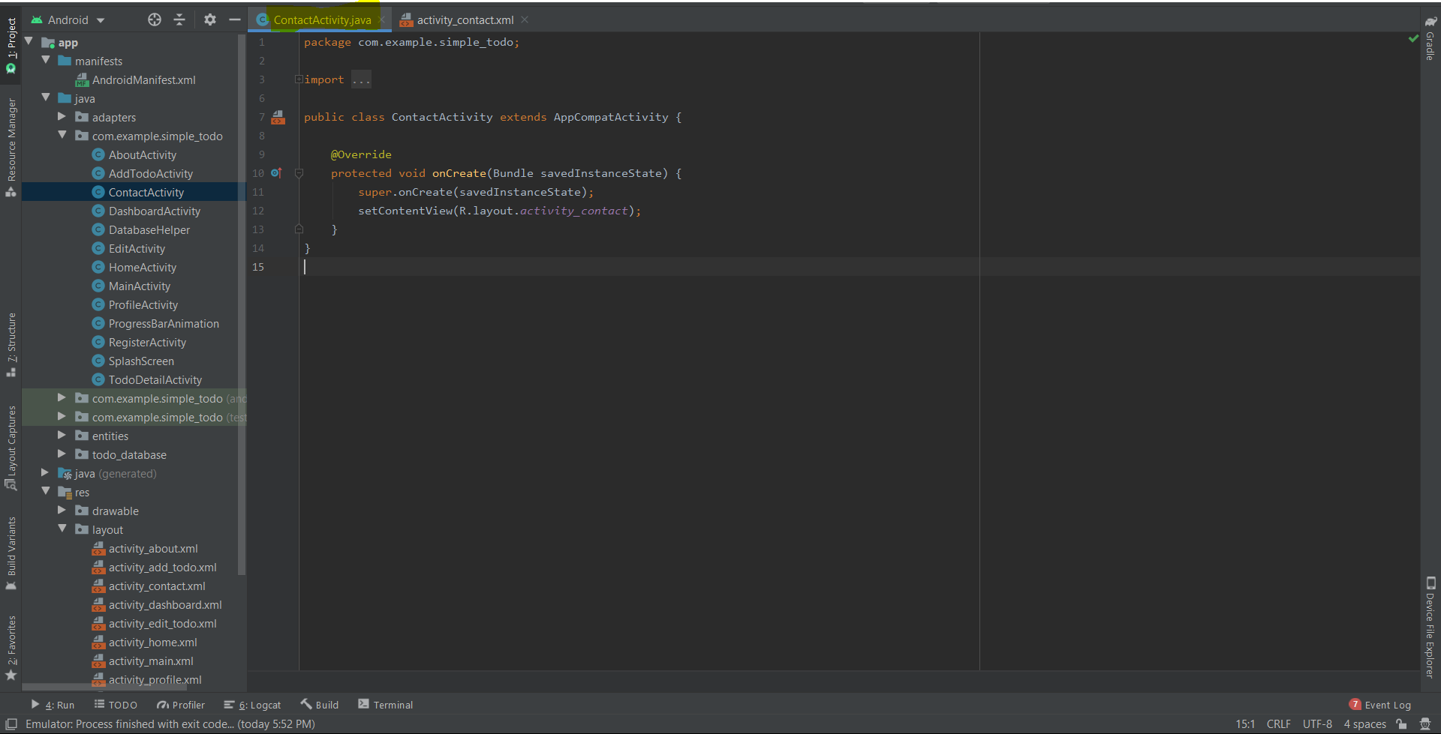

This is java class of contact activity which has no dynamic content for now all the layout is managed through xml file.

### Add To-do activity xml

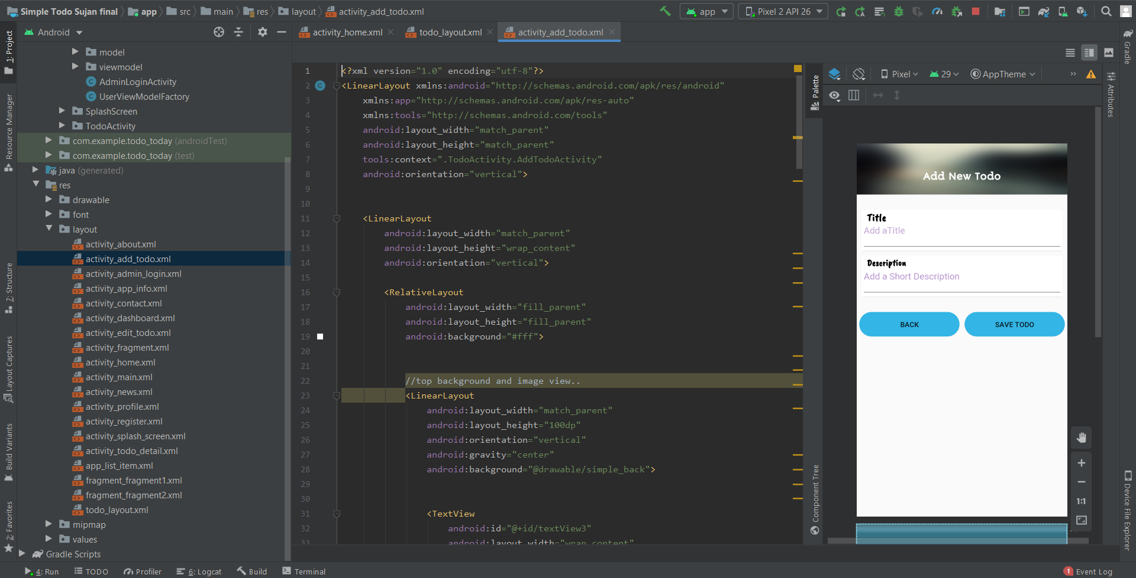

This is the add to-do activity xml screenshot which includes the adding to-do form design layout containing text field and input fields with save and cancel button.

### Add To-do activity java class

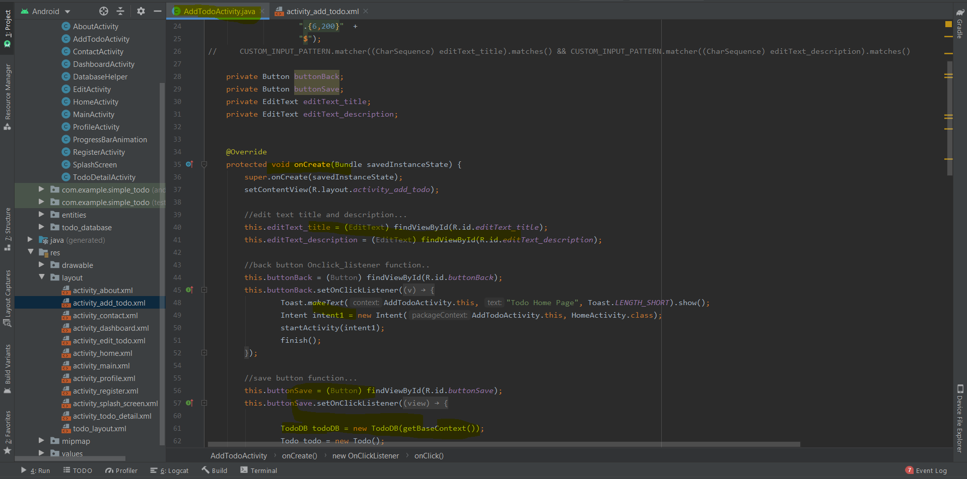

This is java class of add to-do activity which is dynamic content with input field validation to prevent invalid data entry.

### Home/View/Add To-do activity xml

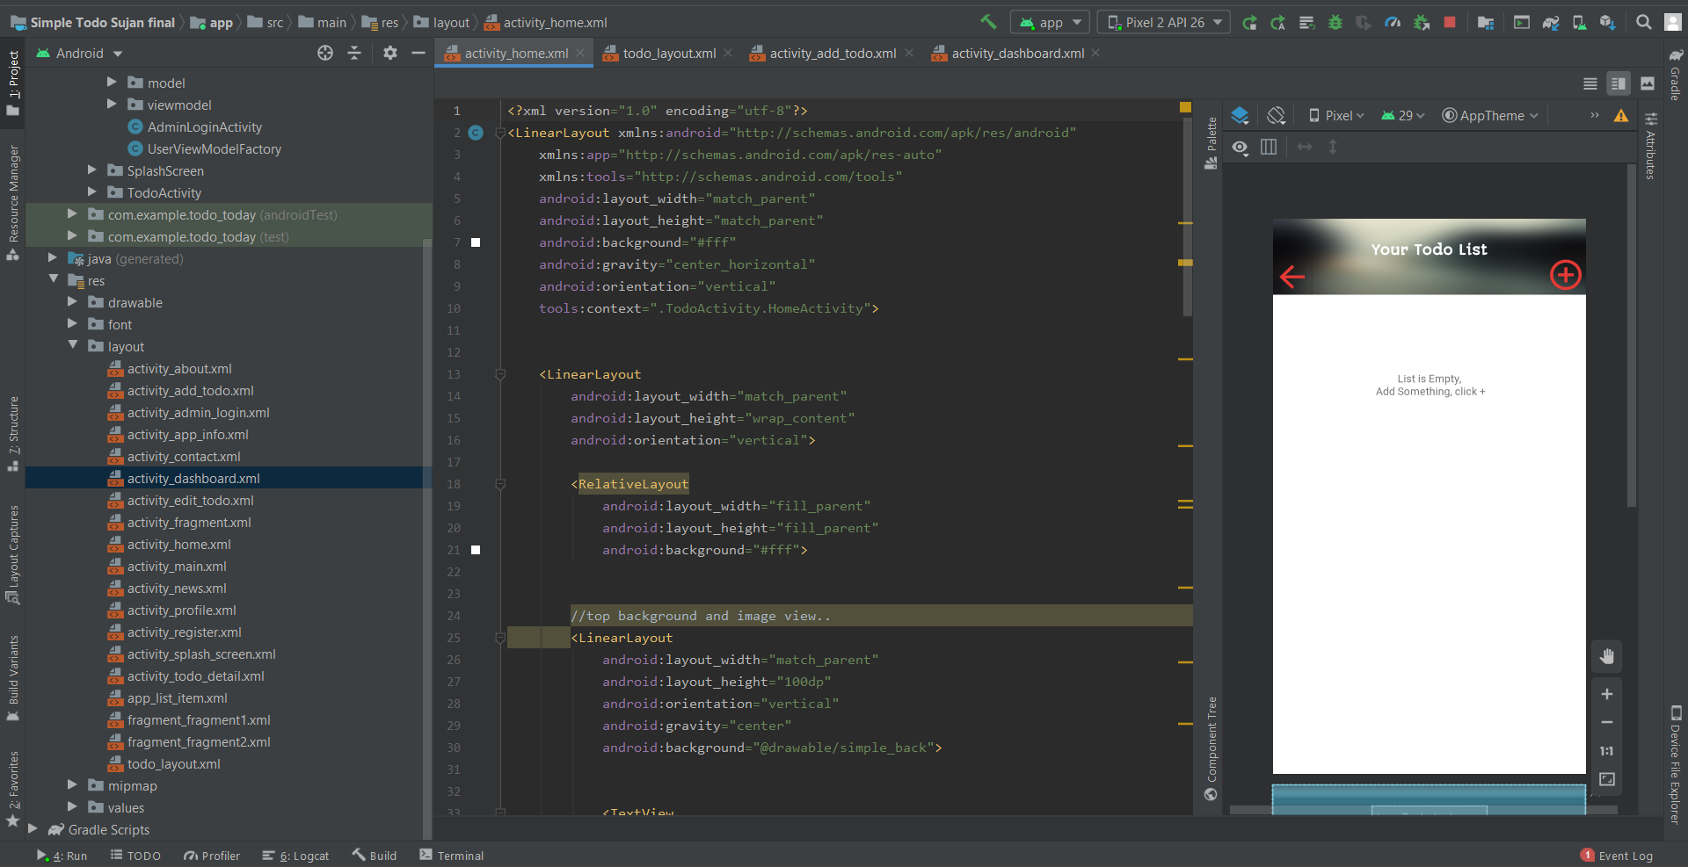

This is the home activity xml screenshot which includes the add and back button with list view to show the added to-do the list is clickable i.e. the list has on click function linked with each newly added to-do id which opens another activity to edit delete and back button options.

### Add To-do activity java class

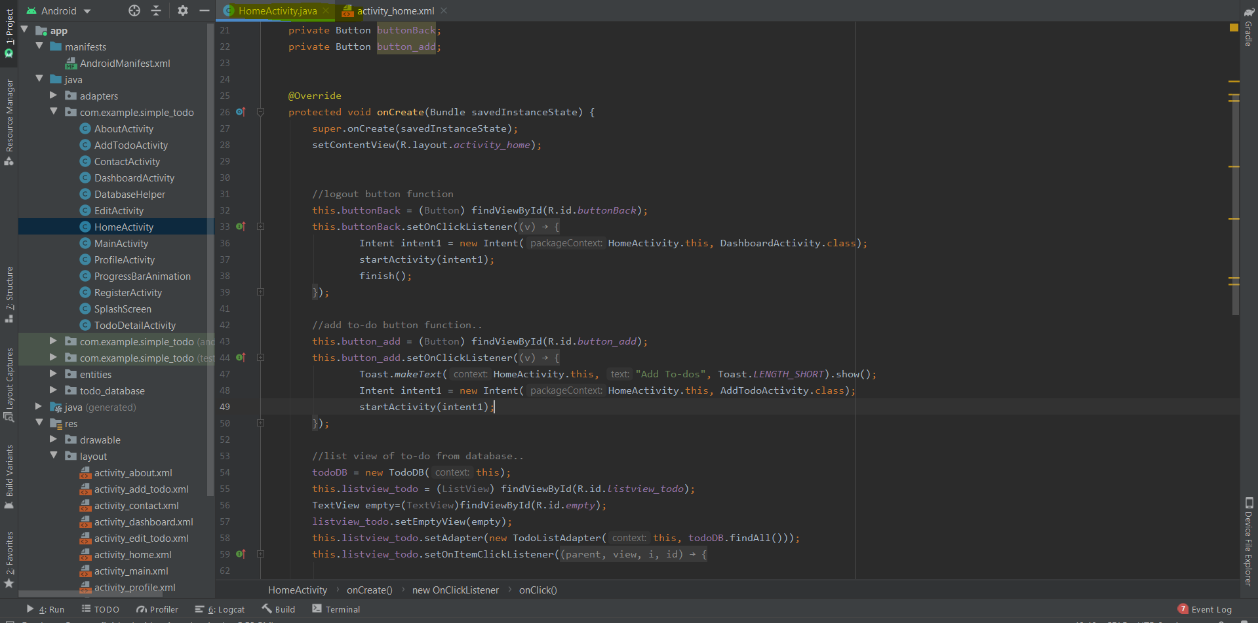

This is java class of home activity which has list-view function along with add or back to dashboard button.

### To-do Detail activity xml

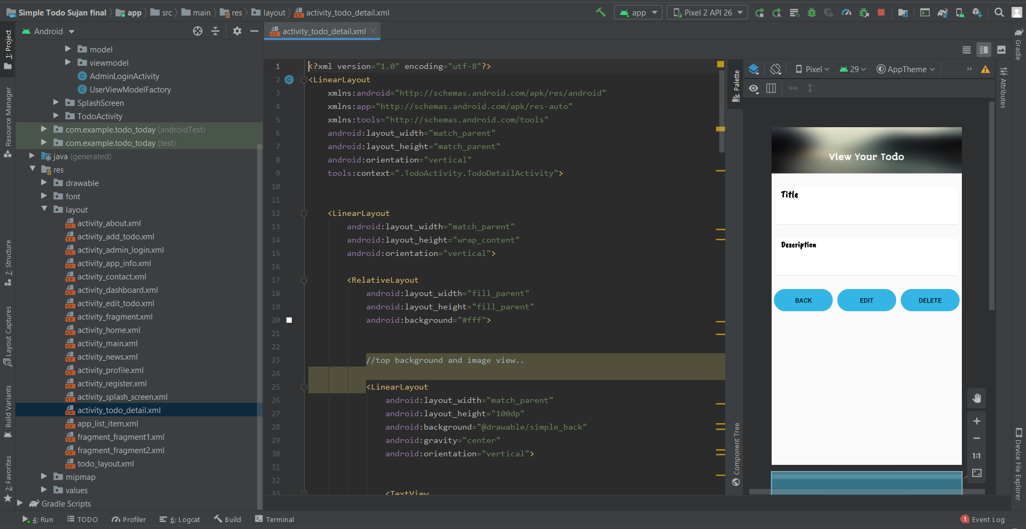

This is the to-do Detail activity xml screenshot which opens after clicking the list view. This contains added to-do data along with edit or delete and back function. Clicking the edit option opens another activity where user can edit their to-do. Delete button deletes the added to-do.

### To-do Detail activity java class

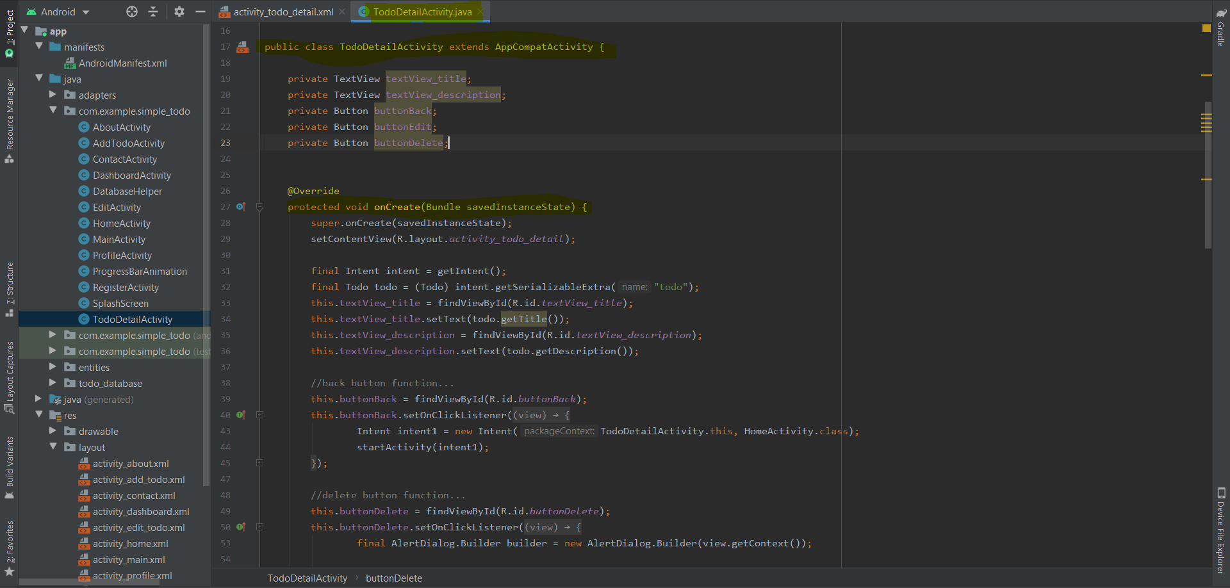

This is to-do detail activity which has many functions showing data, and with 3 buttons back, edit and delete.

### Profile activity xml

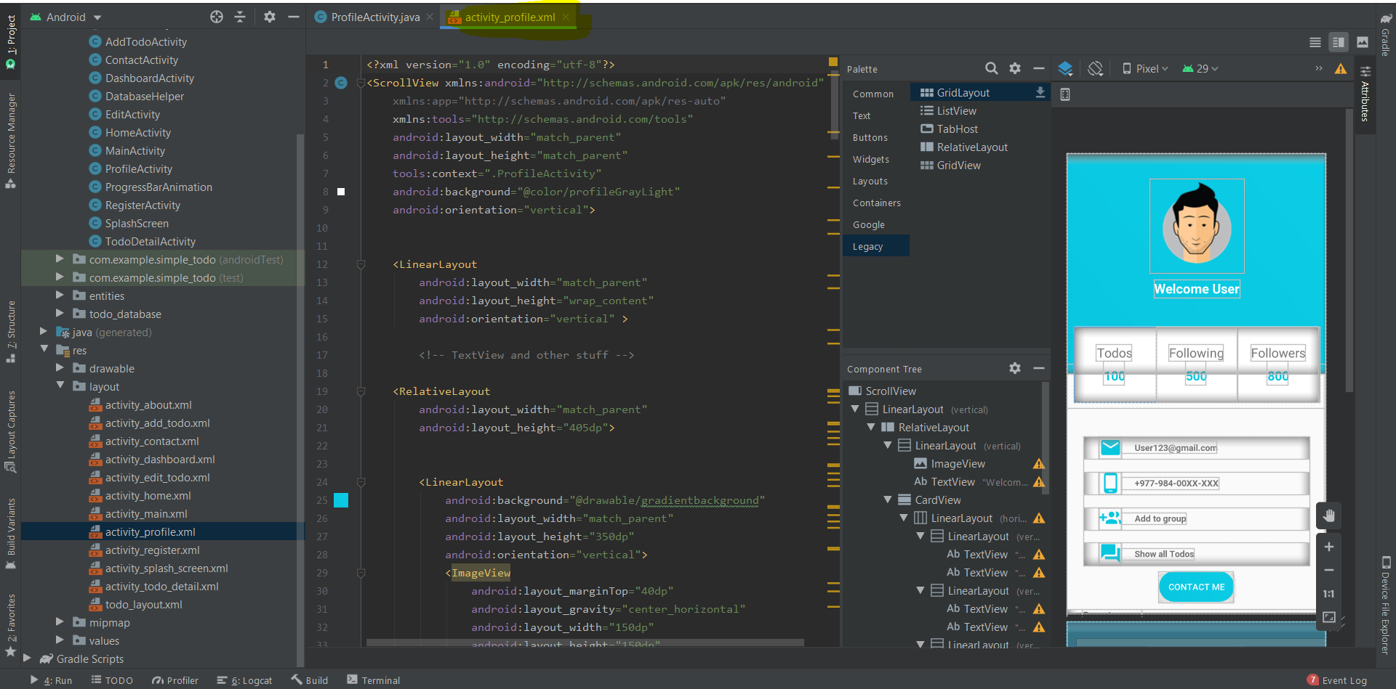

This is profile xml activity contains the user profile design its static for now. This activity includes logo and other details of the user.

### MVVM Admin Login xml

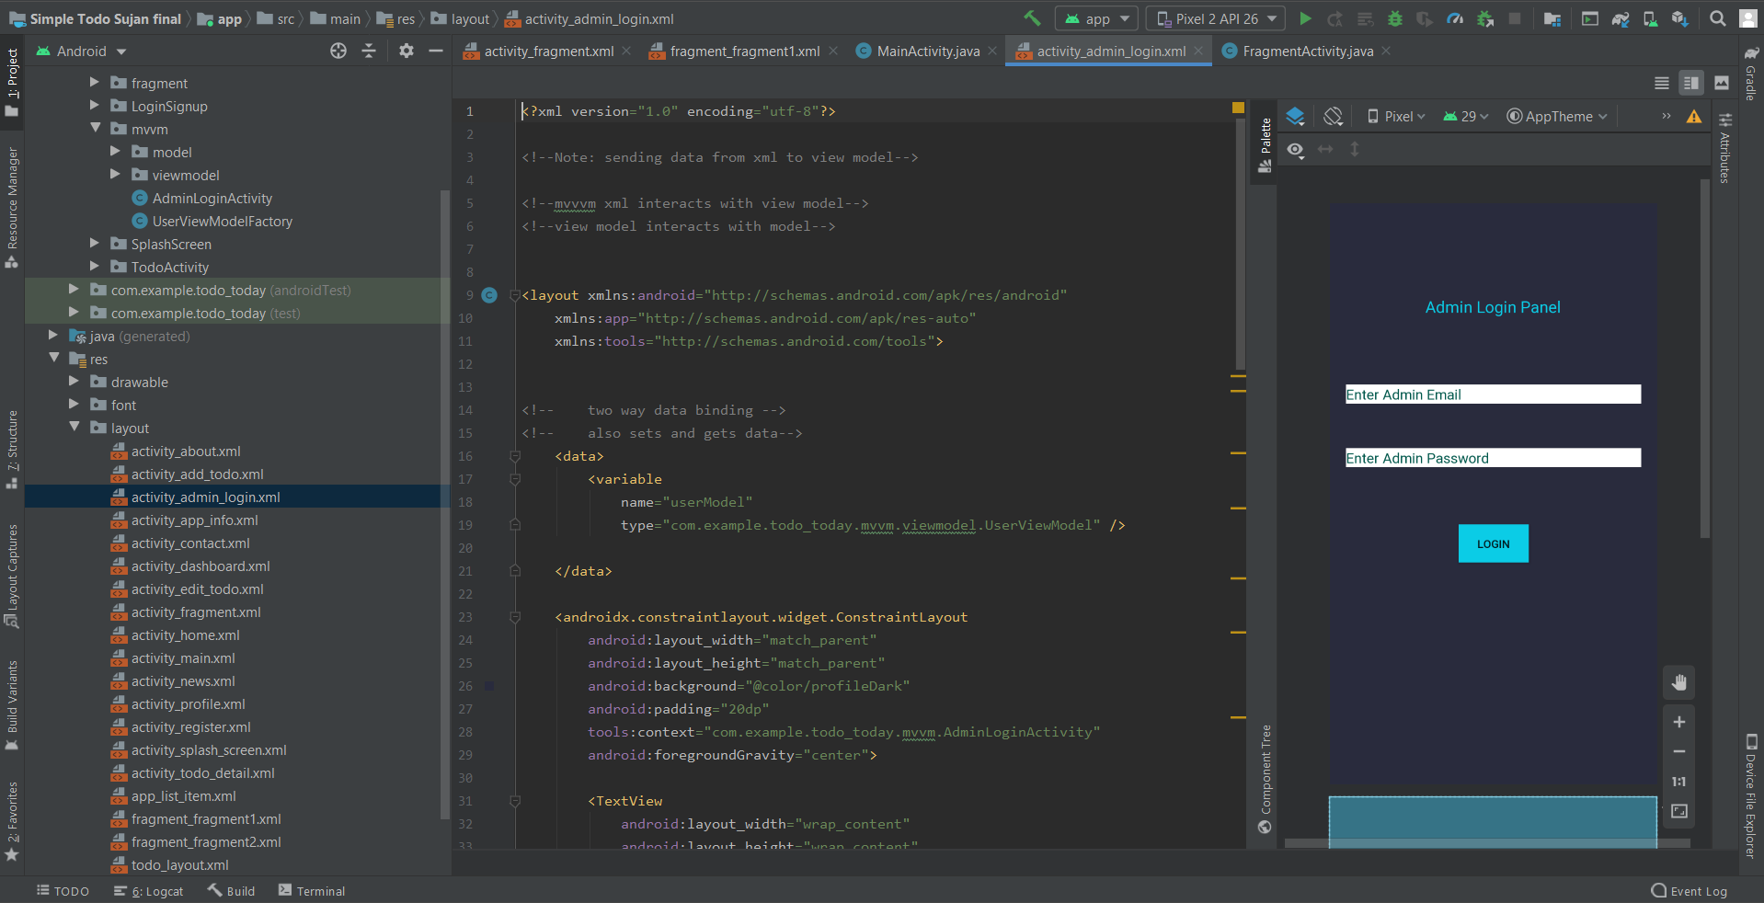

This is admin xml activity created with following mvvm pattern as asked in assignment. This is also a login page for admin dashboard.

### Fragments

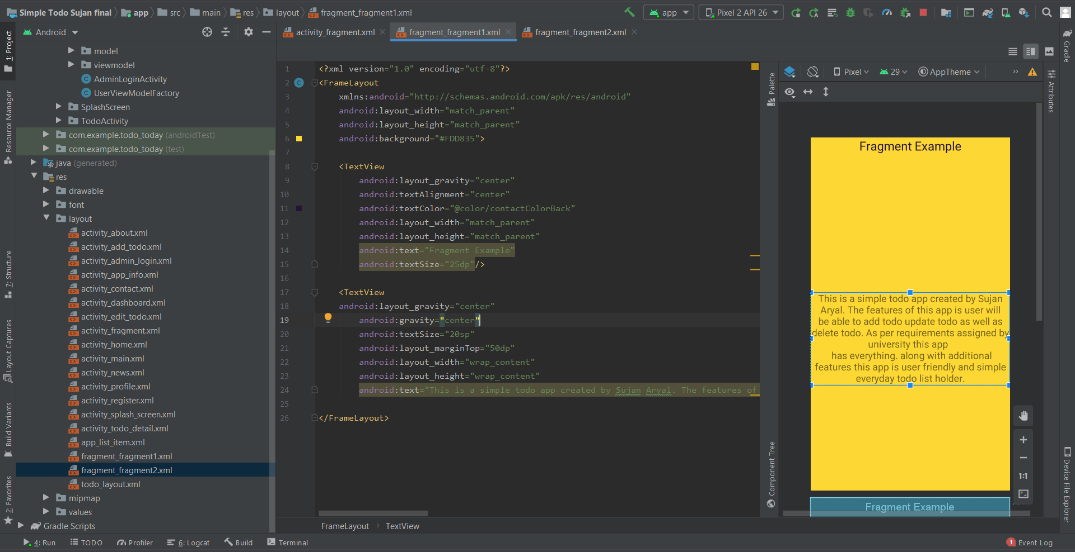

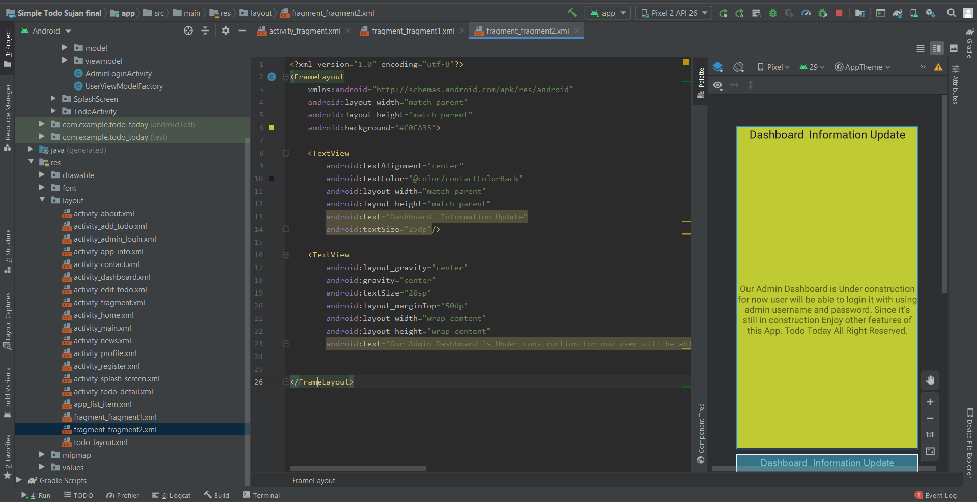

The above figure is fragment xml activity which holds the information about App.

### Profile activity java class

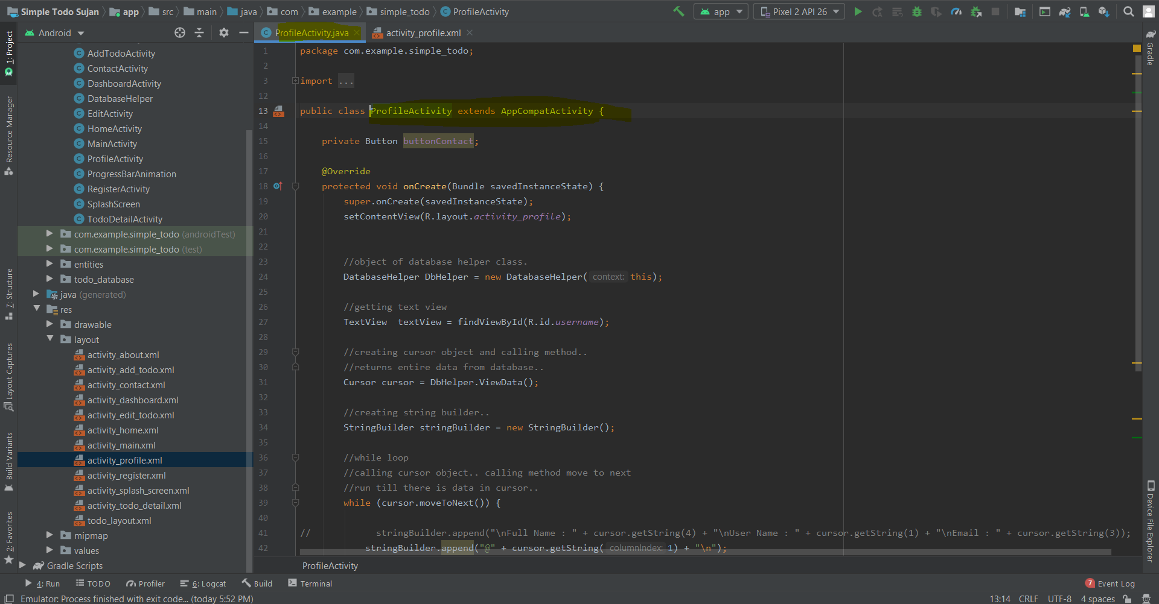

This is java class of profile activity which contains contact button function below.

## Empty field Validations and toast message

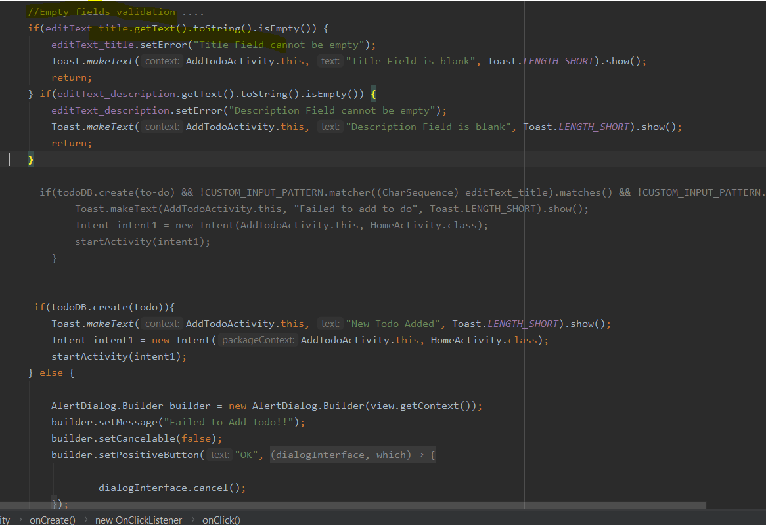

## Database Helper class

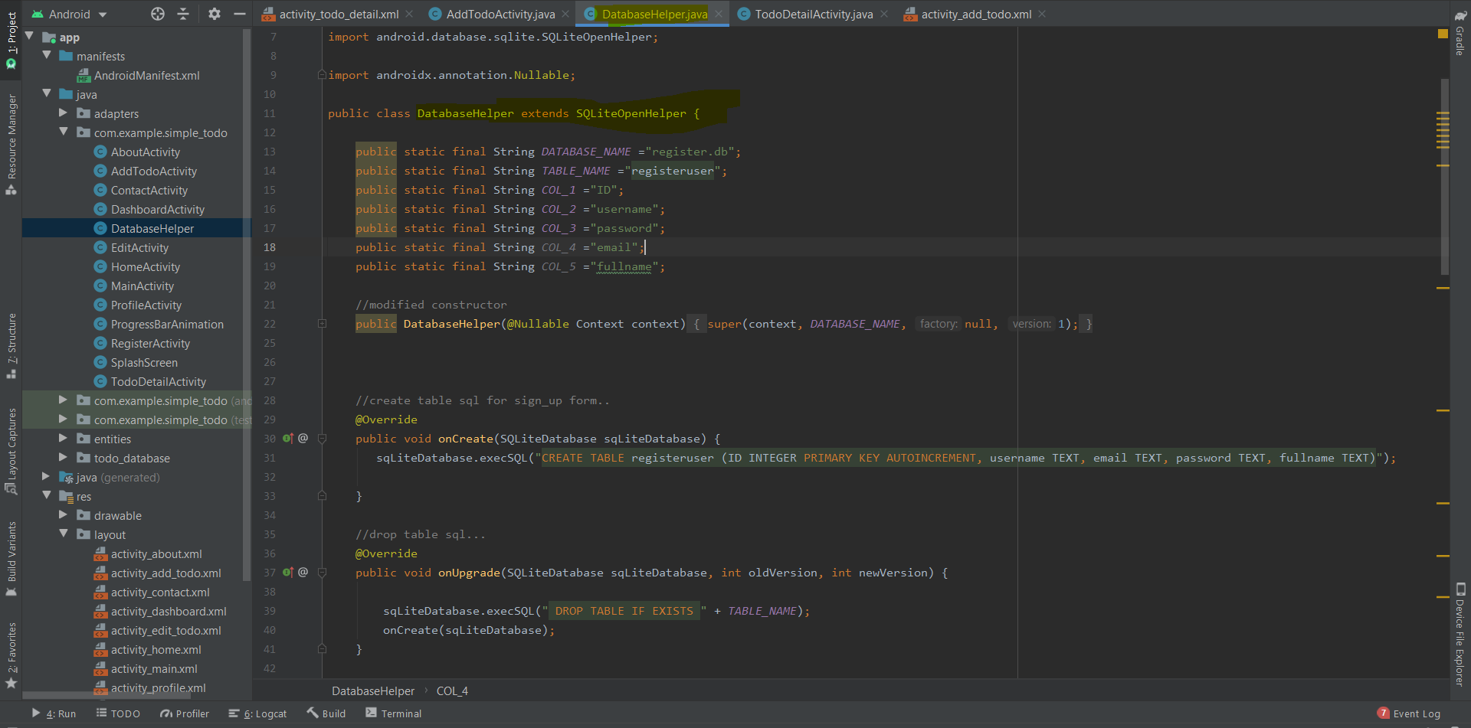

This is database helper class which has table that holds the user data and validates to avoid invalid data entry.

## Progress bar Animation java class

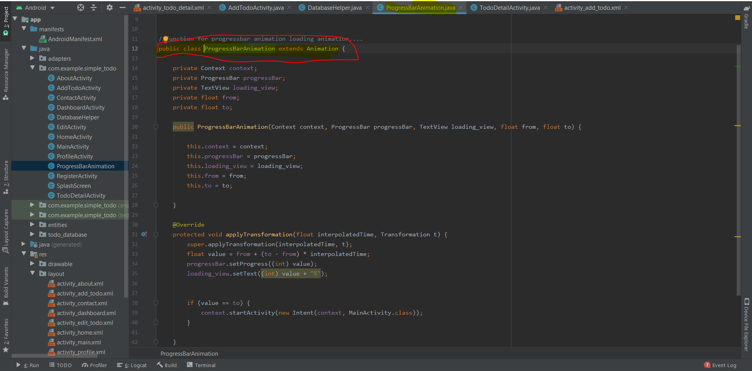

This activity holes function of progress bar animation as splash screen load before loading the app.

## Colors xml activity

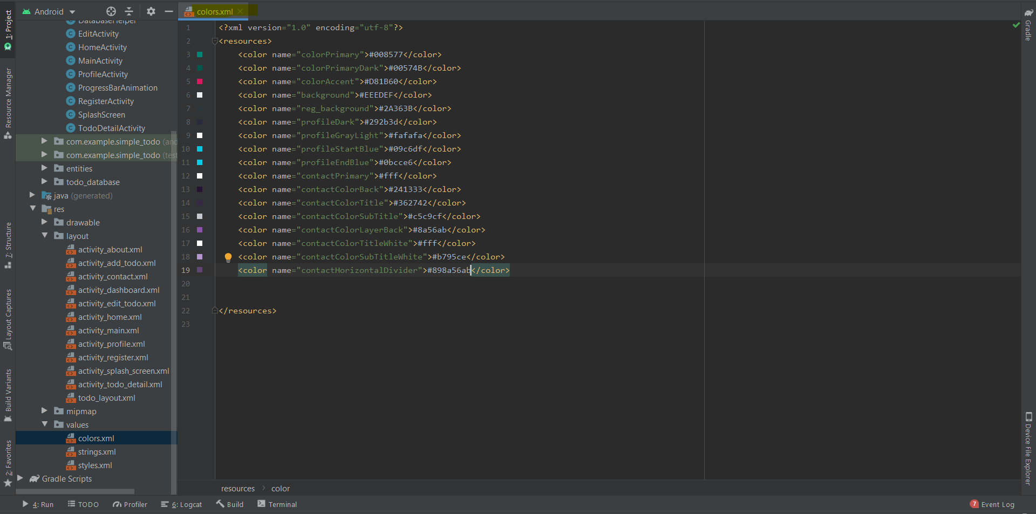

This activity contains the colors that are used in this app.

## Strings xml activity

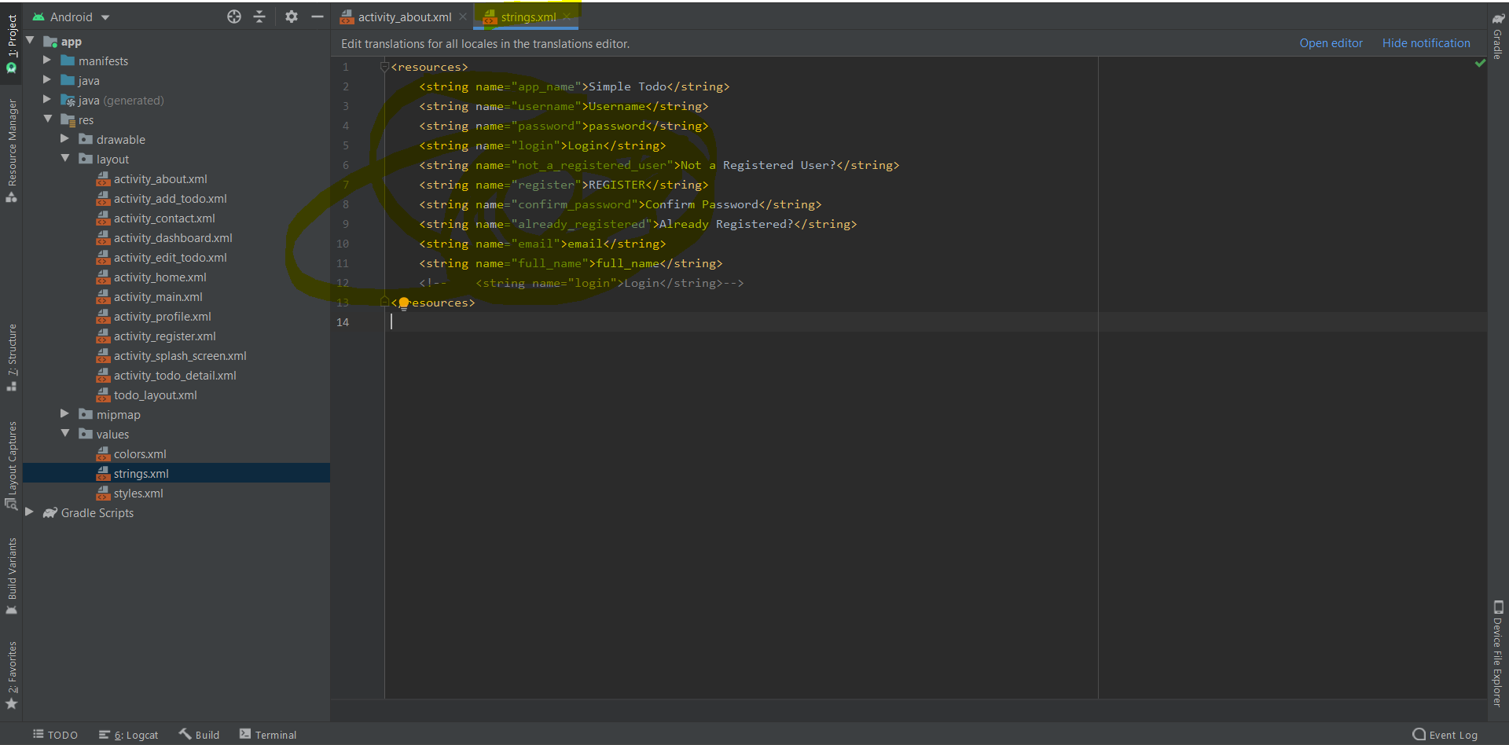

This activity contains the strings that are used in this app.

# Todo Using Orm +room + live data

ORM folder structure

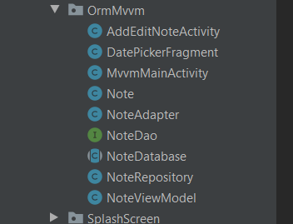

Add edit TODO activity

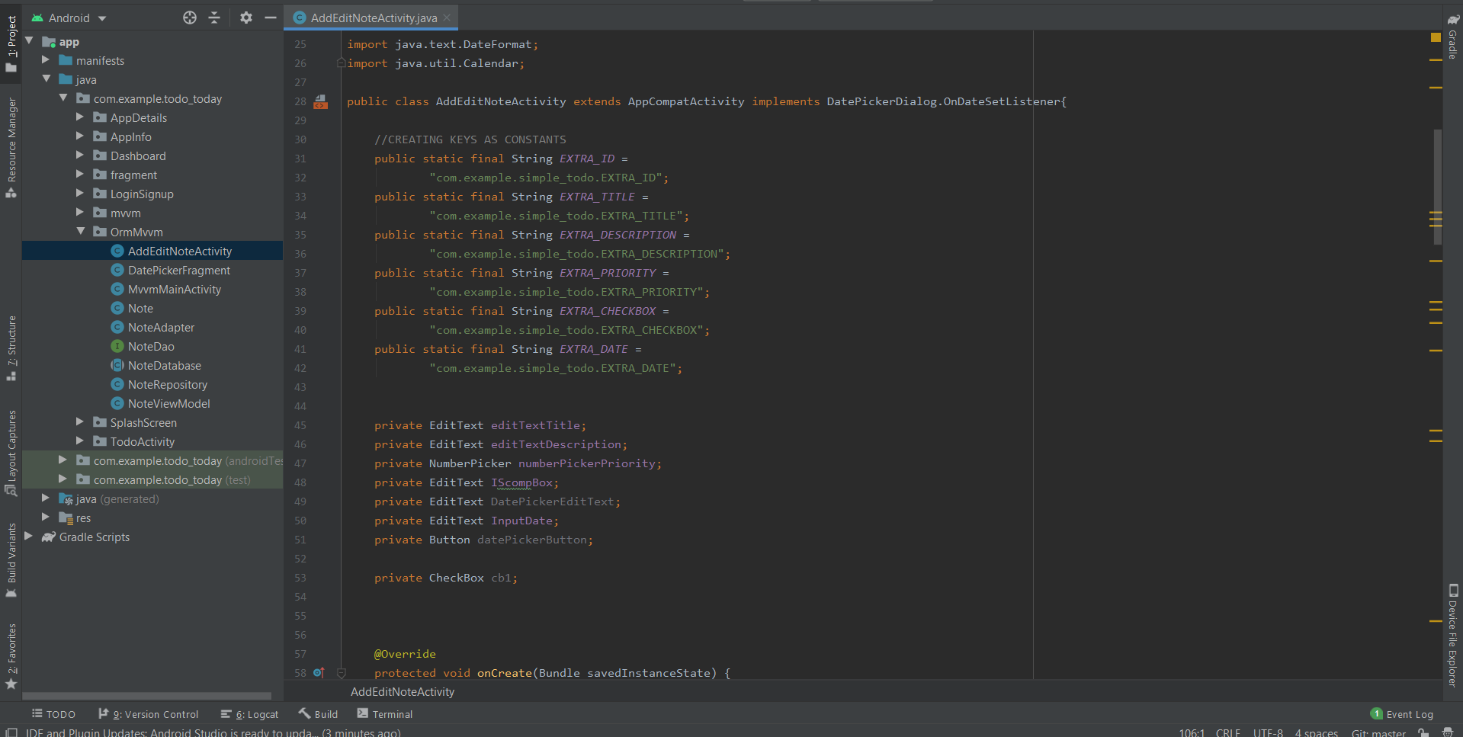

This activity contains add and edit functions related to todo

Dao interface for todo

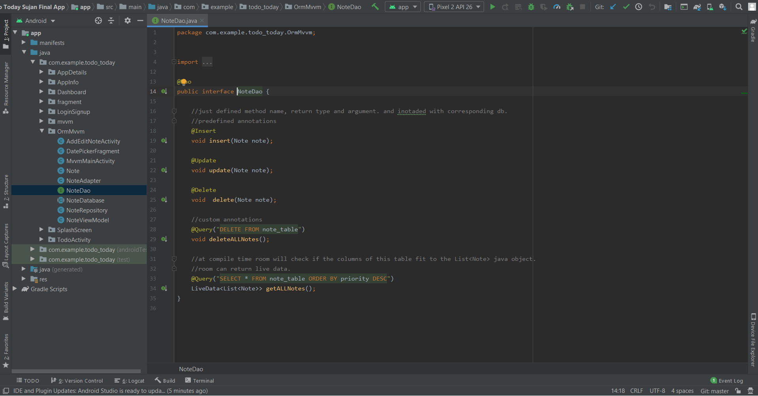

Todo database class orm+room

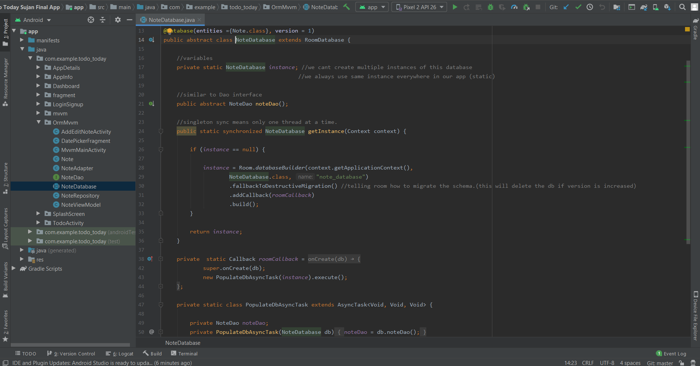

Note.java class(model)

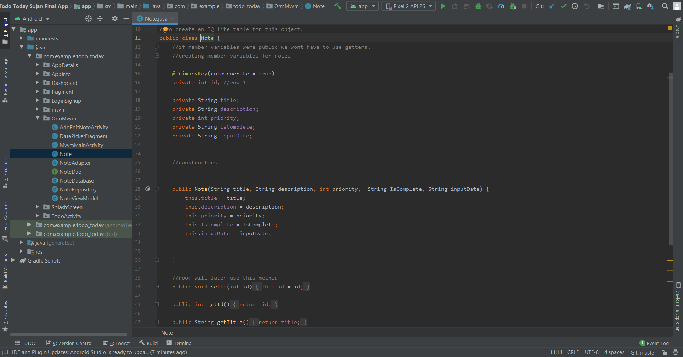

Adapter class for todo orm

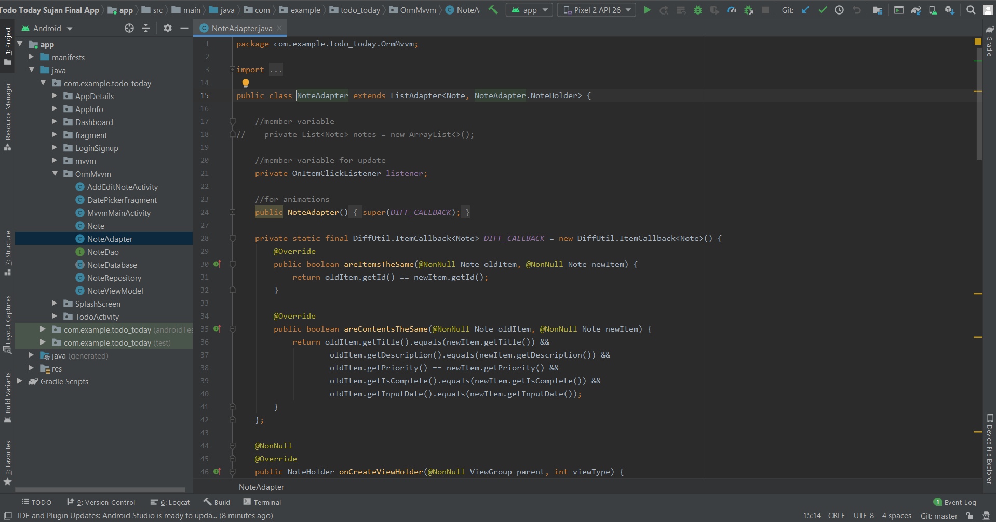

Main activity class for orm

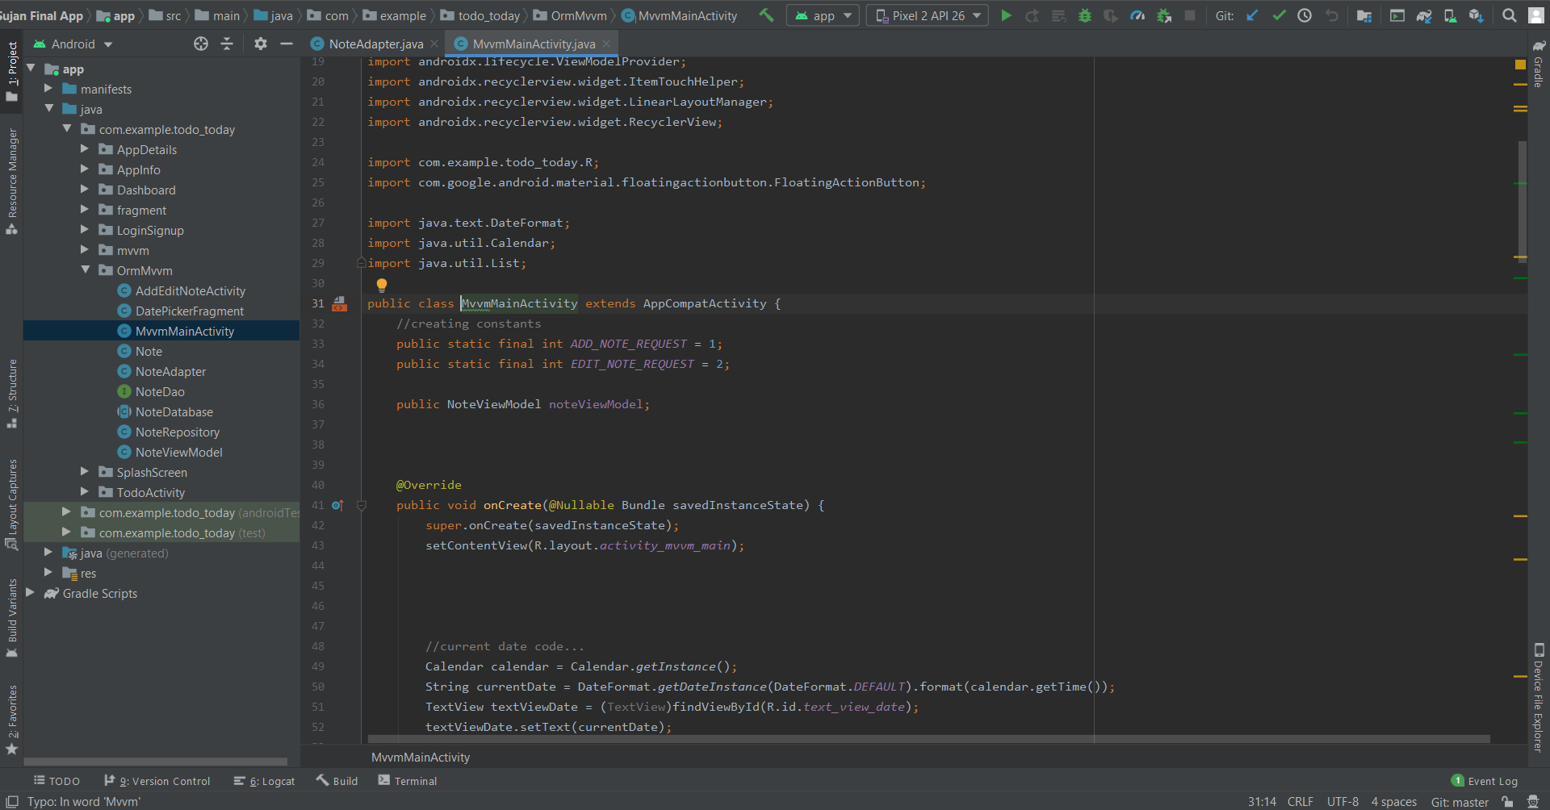

Datepicker class for orm

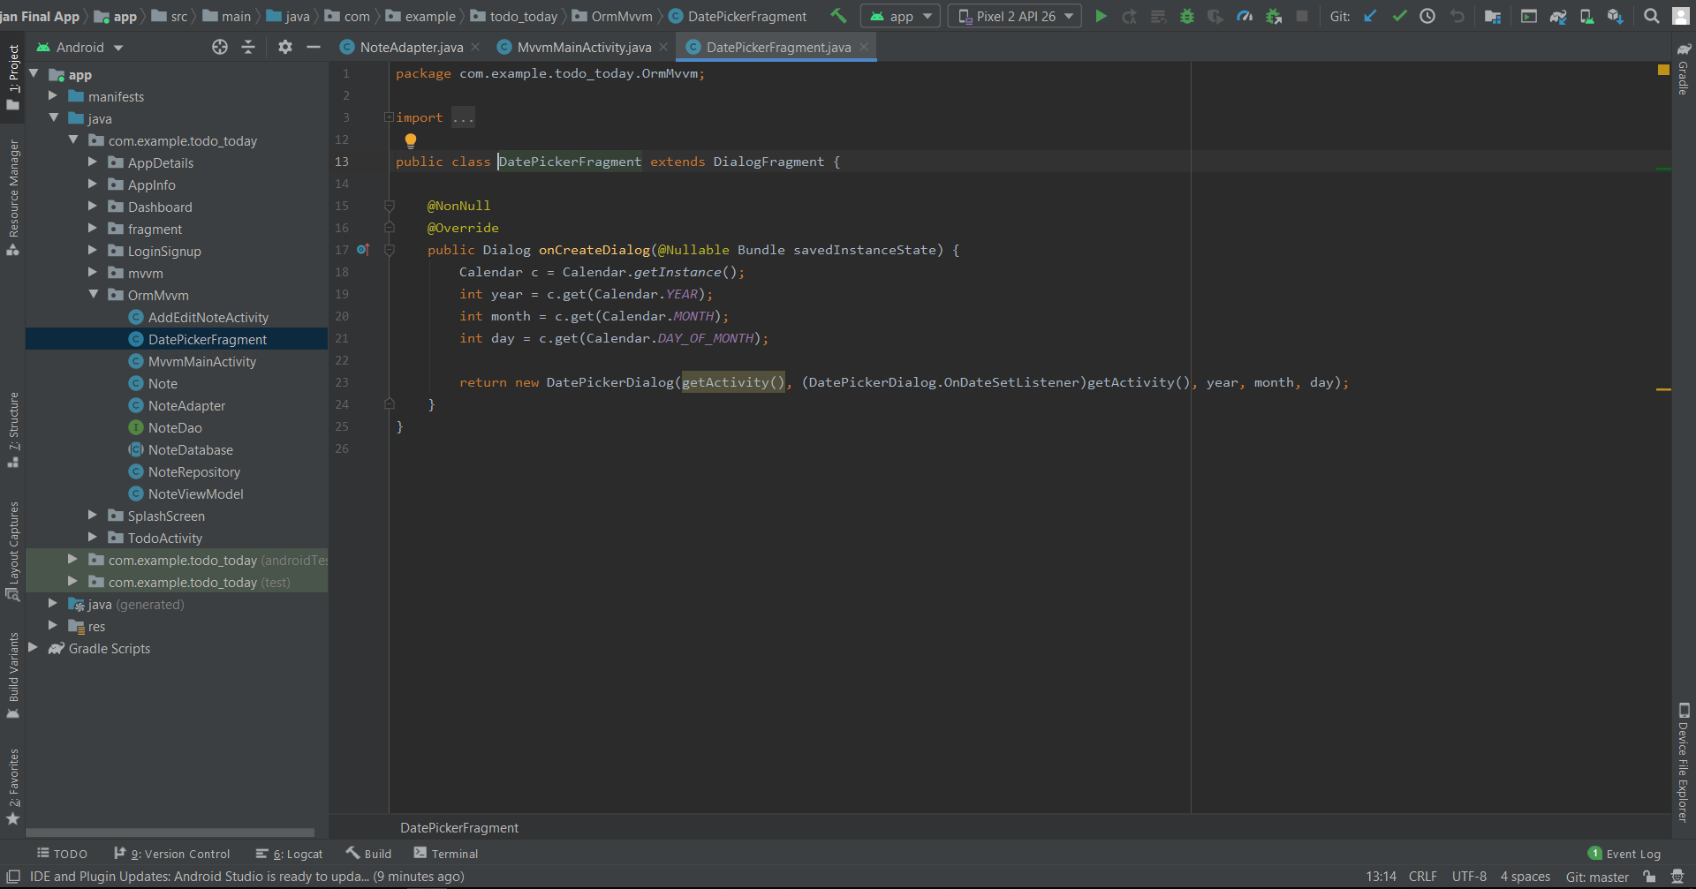

Todo note repository class for orm

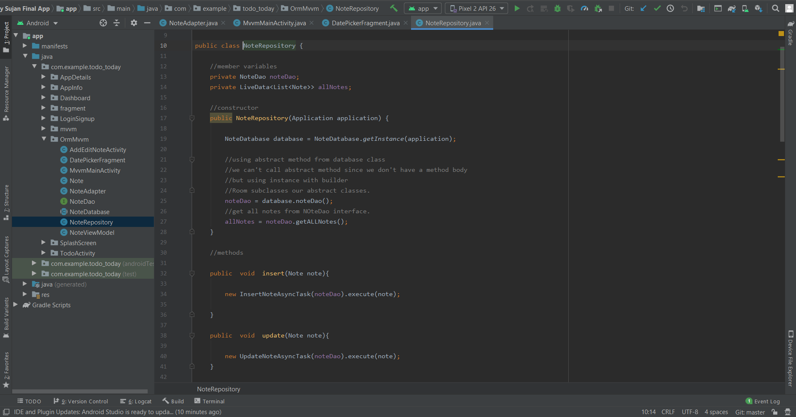

View model of todo

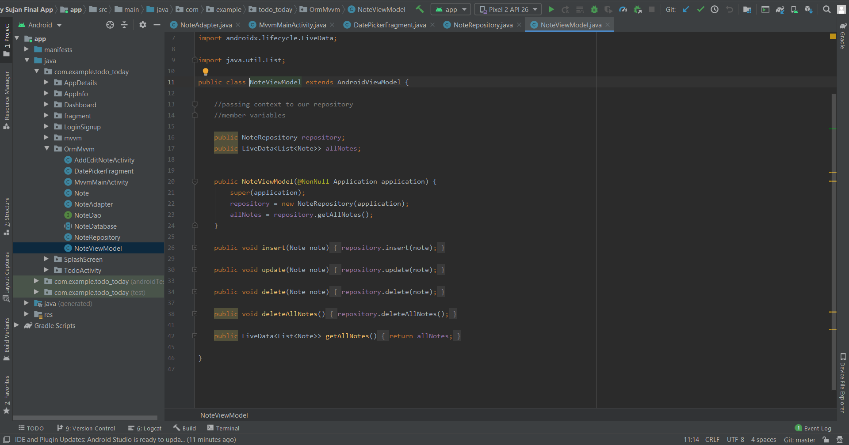

Layout add/edit todo

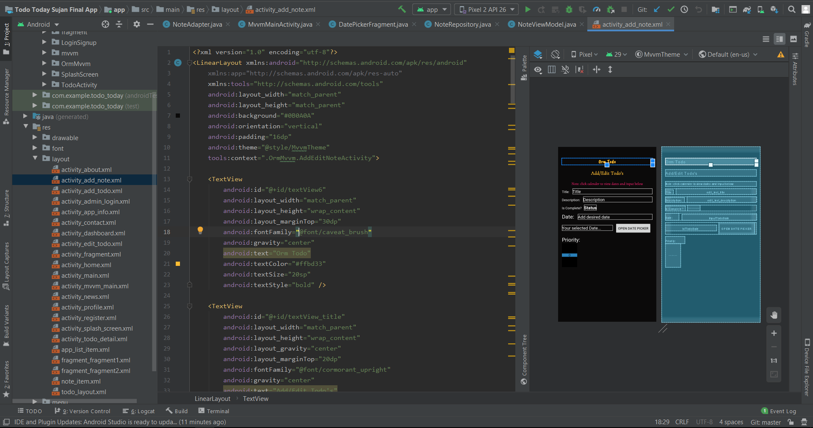

Todo note item layout

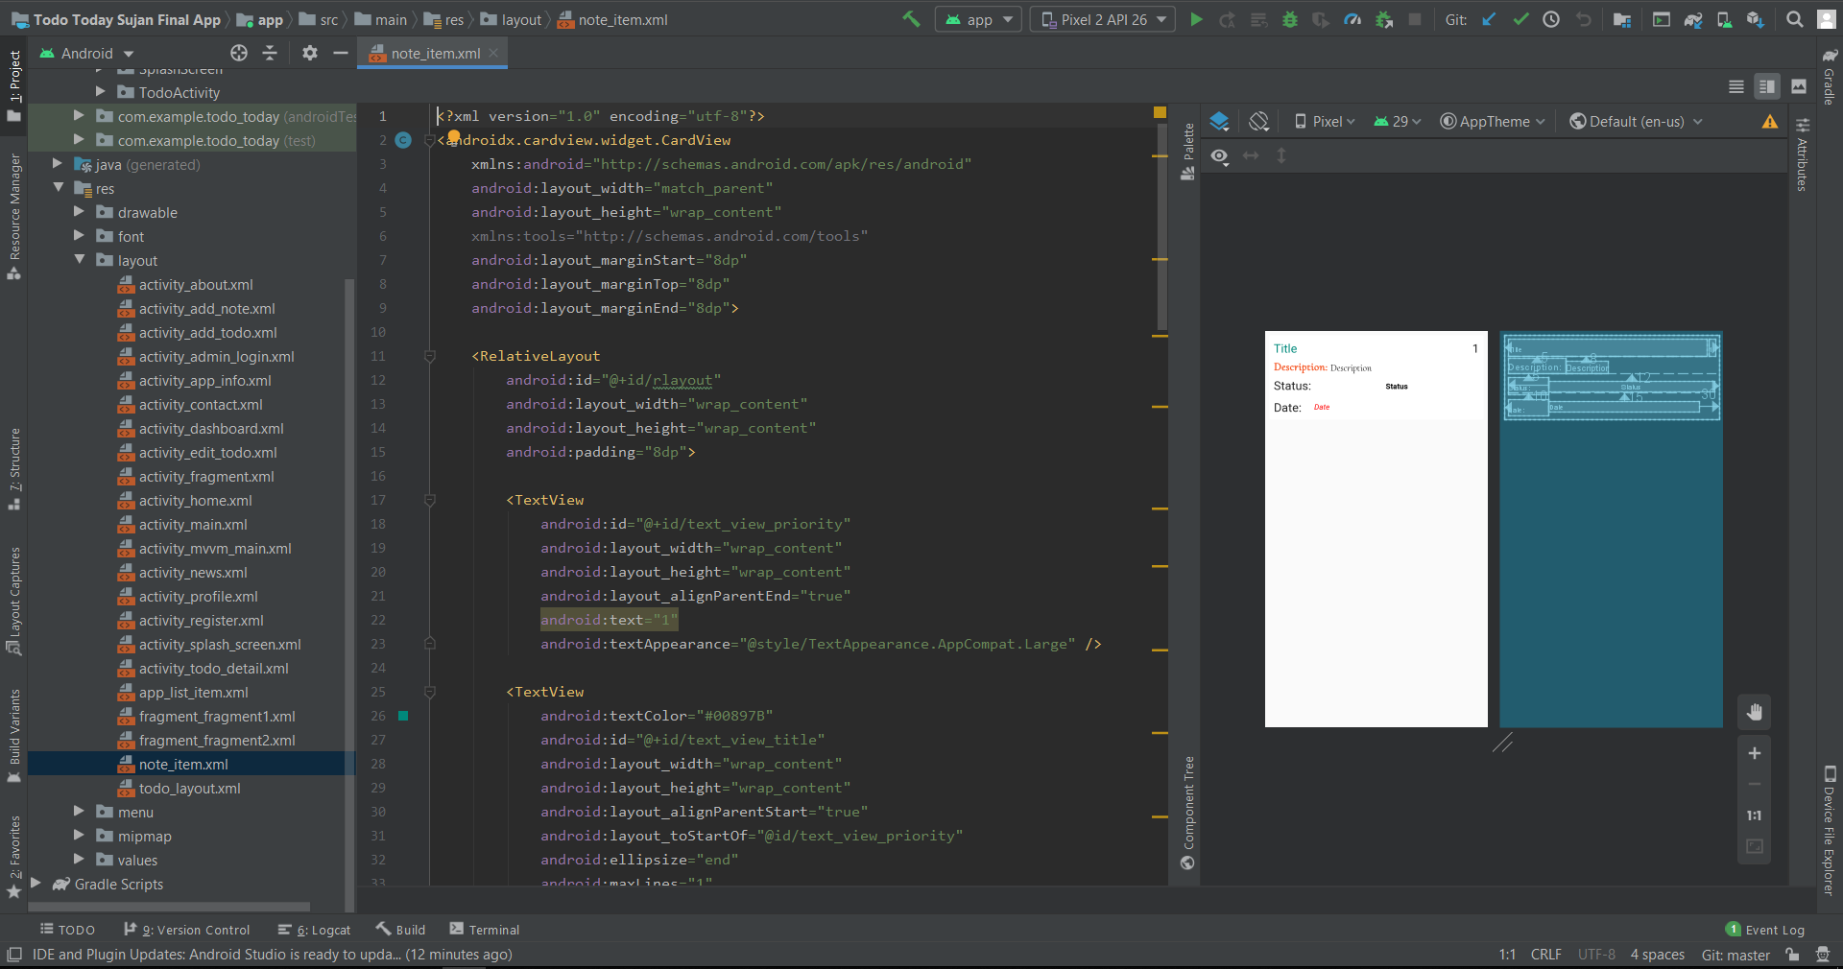

Main activity layout of orm todo note

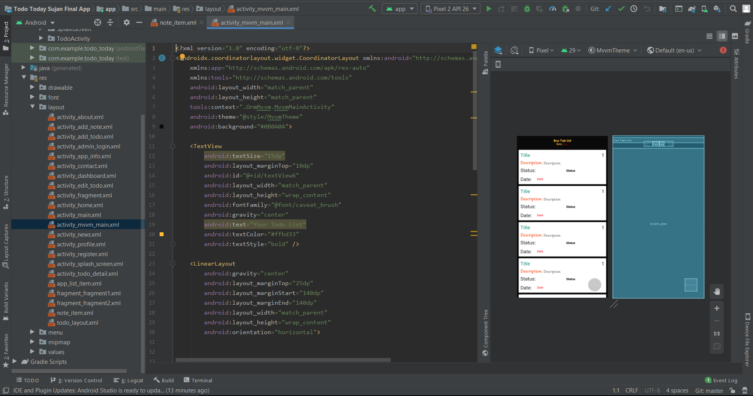

## Additional Screenshots

Below Screenshots contains Profile layout along with input field error and app flow.

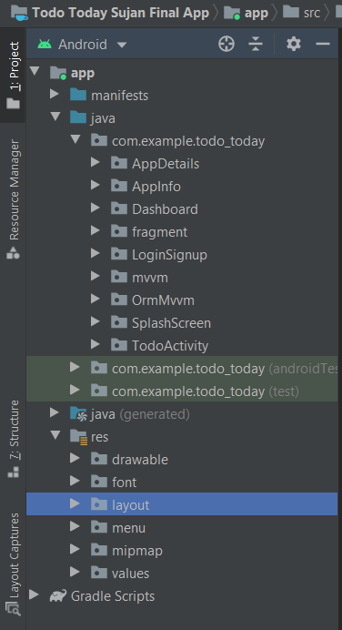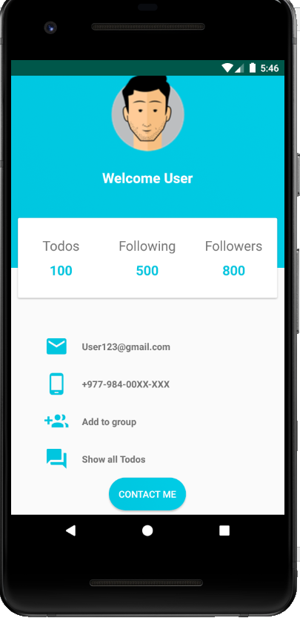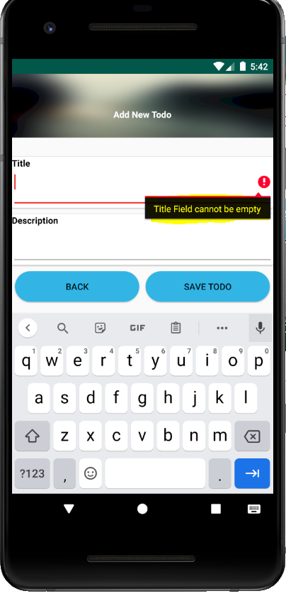

**Thankyou**

